|  |  |
| --- | --- |
| **EX NO:1**  **DATE:9/01/25** | **IMAGE RESIZING,RGB TO GRAY AND HISTOGRAM EQUALISATION** |

**AIM:**



To perform image processing techniques such as image reading, grayscale conversion (automatic and manual), resizing, and histogram equalization (automatic and manual) to enhance image quality and analyze pixel intensity distributions.

**FUNCTIONS USED :**

1. **matplotlib.pyplot.imshow()**:

Displays an image in a Matplotlib plot.

1. **matplotlib.pyplot.axis()**:

Toggles the display of axes in a plot.

1. **cv2.imread()**:

Reads an image from the specified file path.

1. **cv2.cvtColor()**:

Converts an image from one color space to another.

1. **cv2.resize()**:

Resizes an image to the specified dimensions.

1. **numpy.zeros()**:

Creates a new array filled with zeros.

1. **matplotlib.pyplot.subplots()**:

Creates a figure with multiple subplots.

1. **numpy.histogram()**:

Computes the histogram of an image.

1. **matplotlib.pyplot.hist()**:

Plots the histogram of an image.

1. **numpy.cumsum()**:

Computes the cumulative sum of an array.

1. **numpy.ma.masked_equal()**:

Masks an array by replacing a specific value.

12**.matplotlib.pyplot.title()**:

Adds a title to a plot or subplot.

13**.matplotlib.pyplot.show()**:

Renders and displays the plots.

14.**Manual Grayscale Conversion Formula**:

Converts an RGB image to grayscale using a weighted sum of RGB channels.

**ALGORITHM:**

**USING CUSTOM FUNCTION**

1. Load the Image:
   * Read the image from a specified file using matplotlib.image.imread().
2. Check Image Dimensions:
   * Determine if the image is RGB or grayscale by checking its dimensions (img.ndim).
3. Convert to Grayscale (Manual):
   * Use a custom formula to manually convert the RGB image to grayscale: grayscale_image=0.2989⋅R+0.5870⋅G+0.1140⋅B\text{grayscale\_image} = 0.2989 \cdot R + 0.5870 \cdot G + 0.1140 \cdot Bgrayscale_image=0.2989⋅R+0.5870⋅G+0.1140⋅B
4. Histogram Equalization (Manual):
   * Compute the histogram of the grayscale image using numpy.histogram().
   * Normalize the cumulative distribution function (CDF).
   * Apply the equalized CDF to the grayscale image for contrast enhancement.
5. Plot Original and Equalized Images:
   * Display the original grayscale image and the histogram-equalized image side by side using matplotlib.pyplot.imshow().
6. Calculate Histograms:
   * Compute the histogram of the original grayscale image and the equalized image.
   * Display both histograms using matplotlib.pyplot.hist().
7. Resize Image (Manual):
   * Implement a custom nearest-neighbor resizing function to resize the image to a specified size (e.g., 256x256 pixels).
8. Display Resized Image:
   * Display the resized image using matplotlib.pyplot.imshow().
9. Adjust Layout:
   * Use matplotlib.pyplot.tight_layout() to prevent overlap of subplots.
10. Show All Plots:
    * Render and display all images and plots using matplotlib.pyplot.show().

**Read the image**

**CODE:**

import matplotlib.pyplot as plt

import matplotlib.image as mpimg

img = mpimg.imread("C:/Users/admin/Downloads/lena.jpg")

# Display the image

plt.imshow(img)

plt.axis('off')

plt.show()

**OUTPUT**:

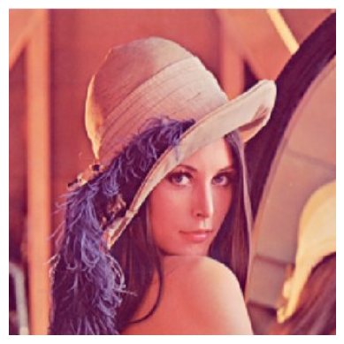

**INFERENCE:**

The code reads and displays an image (lena.jpg) from the specified file path using Matplotlib. It removes the axis and shows the image in a window. If the file path is correct and the image is accessible, it will be displayed successfully

**Convert into grayscale**

**CODE:**

import cv2

import matplotlib.pyplot as plt

img = cv2.imread("C:/Users/admin/Downloads/lena.jpg")  
gray_img = cv2.cvtColor(img, cv2.COLOR_BGR2GRAY)

plt.imshow(gray_img,cmap='gray')

plt.axis('off')

plt.show()

**OUTPUT:**

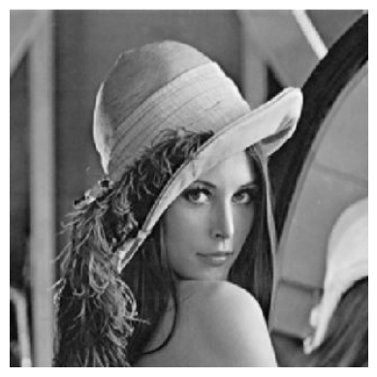

**INFERENCE:**

The code converts an image to grayscale and displays it, with no axes shown around the image. If successful, the image will appear in shades of gray.

**Resize the image**

**CODE:**

resized_img=cv2.resize(gray_img,(640,480))

plt.imshow(resized_img,cmap='gray')

plt.title('resized image')

plt.axis('off') # Hide the axes

plt.show()

**OUTPUT:**

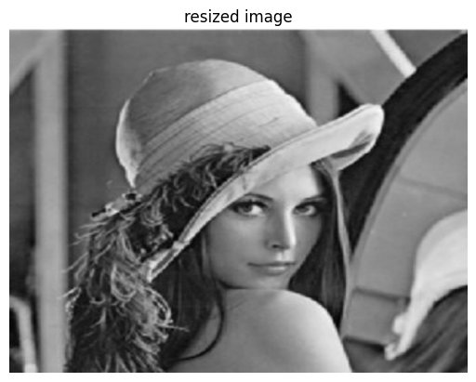

**INFERENCE:**

The code resizes the grayscale image to 640x480 pixels and displays it with the title "resized image" without axes.

**Convert into gray scale manually**

**CODE:**

import matplotlib.pyplot as plt

import matplotlib.image as mpimg

import numpy as np

img = mpimg.imread("C:/Users/admin/Downloads/lena.jpg")

if img.ndim == 3:

grayscale_image = 0.2989 * img[:, :, 0] + 0.5870 * img[:, :, 1] + 0.1140 * img[:, :, 2]

else:

grayscale_image = img

fig, ax = plt.subplots(1, 2, figsize=(10, 5))

ax[0].imshow(img)

ax[0].set_title("Original Image")

ax[0].axis('off')

ax[1].imshow(grayscale_image, cmap='gray')

ax[1].set_title("Grayscale Image")

ax[1].axis('off')

plt.show()

**OUTPUT:**

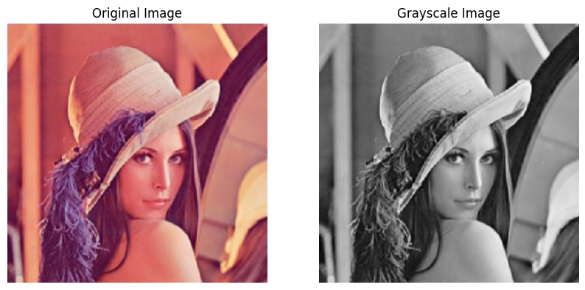

**INFERENCE:**

The code manually converts the image to grayscale using a weighted sum of the RGB channels and then displays both the original and grayscale images side by side.

**Resize the image manually**

**CODE:**

import matplotlib.pyplot as plt

import matplotlib.image as mpimg

import numpy as np

def resize_image_nearest_neighbor(image, new_width, new_height):

old_height, old_width, channels = image.shape

resized_image = np.zeros((new_height, new_width, channels), dtype=np.uint8)

for i in range(new_height):

for j in range(new_width):

# Find the corresponding pixel in the original image

old_i = int(i * old_height / new_height)

old_j = int(j * old_width / new_width)

resized_image[i, j] = image[old_i, old_j]

return resized_image

img = mpimg.imread("C:/Users/admin/Downloads/lena.jpg")

new_width, new_height = 256, 256

resized_img = resize_image_nearest_neighbor(img, new_width, new_height)

fig, ax = plt.subplots(1, 2, figsize=(10, 5))

ax[0].imshow(img)

ax[0].set_title("Original Image")

ax[0].axis('off')

ax[1].imshow(resized_img)

ax[1].set_title("Resized Image")

ax[1].axis('off')

plt.show()

**OUTPUT:**

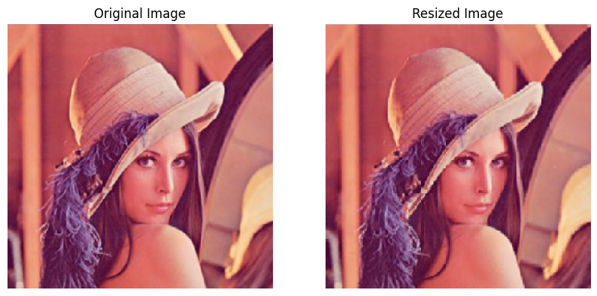

**INFERENCE:**

The code resizes the image from its original size to 256x256 pixels using nearest neighbor interpolation and then displays both the original and resized images side by side.

**Histogram equalisation**

**CODE:**

import cv2

import matplotlib.pyplot as plt

img = cv2.imread("C:/Users/admin/Downloads/lena.jpg")

gray_img = cv2.cvtColor(img, cv2.COLOR_BGR2GRAY)

img_equalized = cv2.equalizeHist(gray_img)

fig, ax = plt.subplots(1, 2, figsize=(12, 6))

ax[0].imshow(gray_img, cmap='gray')

ax[0].set_title("Original Image")

ax[0].axis('off')

ax[1].imshow(img_equalized, cmap='gray')

ax[1].set_title("Equalized Image")

ax[1].axis('off')

plt.show()

fig, ax = plt.subplots(1, 2, figsize=(12, 6))

ax[0].hist(gray_img.flatten(), bins=256, range=[0, 256], color='gray')

ax[0].set_title("Original Histogram")

ax[1].hist(img_equalized.flatten(), bins=256, range=[0, 256], color='gray')

ax[1].set_title("Equalized Histogram")

plt.show()

**OUTPUT:**

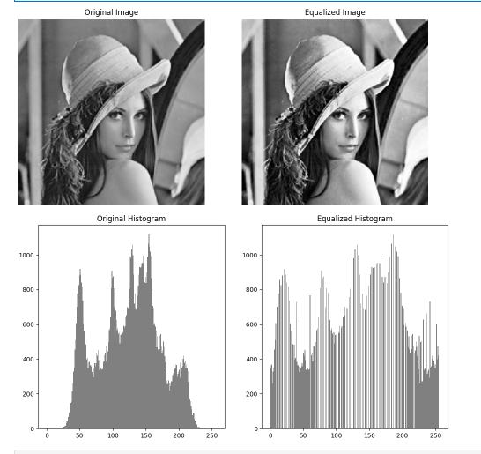

**INFERENCE:**

Histogram equalization improves image contrast by redistributing intensity values, spreads the histogram uniformly, and enhances visibility of details.

**Histogram equalisation manual**

**CODE:**

import matplotlib.pyplot as plt

import numpy as np

import matplotlib.image as mpimg

def histogram_equalization_manual(gray_img):

hist, bins = np.histogram(gray_img.flatten(), bins=256, range=[0, 256])

cdf = hist.cumsum()

cdf_normalized = cdf * float(hist.max()) / cdf.max()

cdf_m = np.ma.masked_equal(cdf, 0)

cdf_m = (cdf_m - cdf_m.min()) * 255 / (cdf_m.max() - cdf_m.min())

cdf = np.ma.filled(cdf_m, 0).astype('uint8')

gray_img = gray_img.astype(np.uint8)

img_equalized = cdf[gray_img]

return img_equalized

img = mpimg.imread("C:/Users/admin/Downloads/lena.jpg")

if img.ndim == 3:

gray_img = 0.2989 * img[:, :, 0] + 0.5870 * img[:, :, 1] + 0.1140 * img[:, :, 2]

else:

gray_img = img

img_equalized = histogram_equalization_manual(gray_img)

fig, ax = plt.subplots(1, 2, figsize=(12, 6))

ax[0].imshow(gray_img, cmap='gray')

ax[0].set_title("Original Image")

ax[0].axis('off')

ax[1].imshow(img_equalized, cmap='gray')

ax[1].set_title("Equalized Image")

ax[1].axis('off')

plt.show()

fig, ax = plt.subplots(1, 2, figsize=(12, 6))

ax[0].hist(gray_img.flatten(), bins=256, range=[0, 256], color='gray')

ax[0].set_title("Original Histogram")

ax[1].hist(img_equalized.flatten(), bins=256, range=[0, 256], color='gray')

ax[1].set_title("Equalized Histogram")

plt.show()

**OUTPUT:**

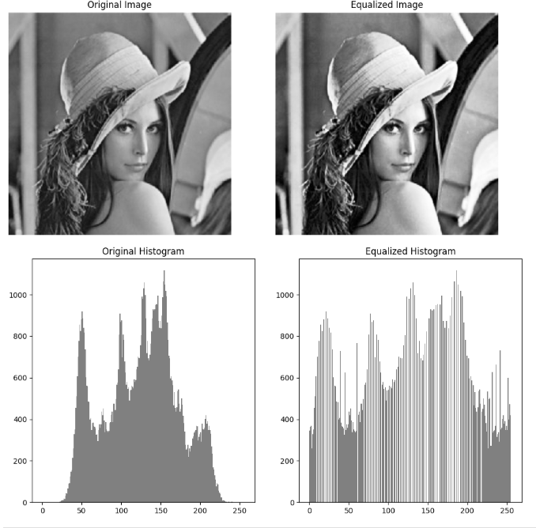

**INFERENCE:**

Manual histogram equalization enhances image contrast by redistributing intensity values using the normalized CDF, making details clearer and spreading the histogram uniformly.

**Read the image**

**Code:**

import matplotlib.pyplot as plt

import matplotlib.image as mpimg

img = mpimg.imread("C:/Users/yuval/Downloads/Elephant-Drawing.jpg")

# Display the image

plt.imshow(img)

plt.axis('off')

plt.show()

**OUTPUT:**

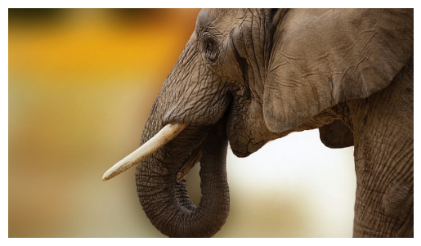

**INFERENCE:**

The code reads and displays an image (lena.jpg) from the specified file path using Matplotlib. It removes the axis and shows the image in a window. If the file path is correct and the image is accessible, it will be displayed successfully

**Convert into grayscale**

**CODE:**

import cv2

import matplotlib.pyplot as plt

img = cv2.imread("C:/Users/yuval/Downloads/Elephant-Drawing.jpg")

gray_img = cv2.cvtColor(img, cv2.COLOR_BGR2GRAY)

plt.imshow(gray_img,cmap='gray')

plt.axis('off')  # Hide the axes

plt.show()

**OUTPUT:**

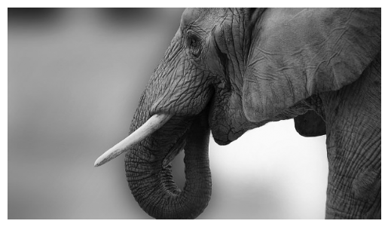

**INFERENCE:**

The code converts an image to grayscale and displays it, with no axes shown around the image. If successful, the image will appear in shades of gray**.**

**Resize the image**

**CODE:**

resized_img=cv2.resize(gray_img,(640,480))

plt.imshow(resized_img,cmap='gray')

plt.title('resized image')

plt.axis('off')  # Hide the axes

plt.show()

**OUTPUT:**

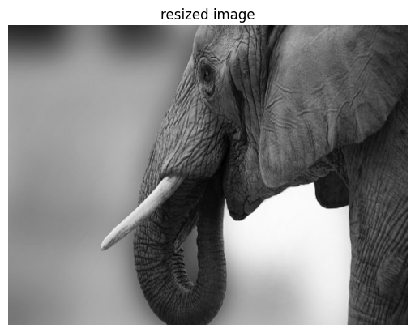

**INFERENCE:**

The code resizes the grayscale image to 640x480 pixels and displays it with the title "resized image" without axes.

**Convert into gray scale manually**

**CODE:**

import matplotlib.pyplot as plt

import matplotlib.image as mpimg

import numpy as np

img = mpimg.imread("C:/Users/yuval/Downloads/Elephant-Drawing.jpg")

if img.ndim == 3:

    grayscale_image = 0.2989 * img[:, :, 0] + 0.5870 * img[:, :, 1] + 0.1140 * img[:, :, 2]

else:

    grayscale_image = img

fig, ax = plt.subplots(1, 2, figsize=(10, 5))

ax[0].imshow(img)

ax[0].set_title("Original Image")

ax[0].axis('off')

ax[1].imshow(grayscale_image, cmap='gray')

ax[1].set_title("Grayscale Image")

ax[1].axis('off')

plt.show()

**OUTPUT:** 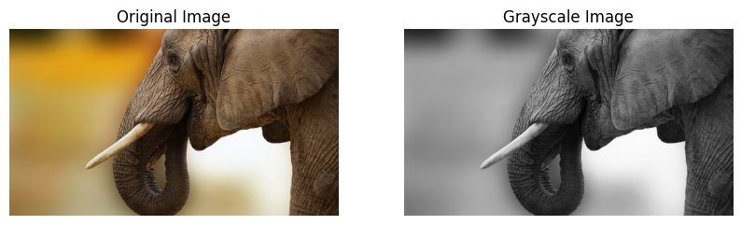

**INFERENCE:**

The code manually converts the image to grayscale using a weighted sum of the RGB channels and then displays both the original and grayscale images side by side.

**Resize the image manually**

**CODE:**

import matplotlib.pyplot as plt

import matplotlib.image as mpimg

import numpy as np

def resize_image_nearest_neighbor(image, new_width, new_height):

    old_height, old_width, channels = image.shape

    resized_image = np.zeros((new_height, new_width, channels), dtype=np.uint8)

    for i in range(new_height):

        for j in range(new_width):

            # Find the corresponding pixel in the original image

            old_i = int(i * old_height / new_height)

            old_j = int(j * old_width / new_width)

            resized_image[i, j] = image[old_i, old_j]

    return resized_image

img = mpimg.imread("C:/Users/yuval/Downloads/Elephant-Drawing.jpg")

new_width, new_height = 256, 256

resized_img = resize_image_nearest_neighbor(img, new_width, new_height)

fig, ax = plt.subplots(1, 2, figsize=(10, 5))

ax[0].imshow(img)

ax[0].set_title("Original Image")

ax[0].axis('off')

ax[1].imshow(resized_img)

ax[1].set_title("Resized Image")

ax[1].axis('off')

plt.show()

**OUTPUT:**

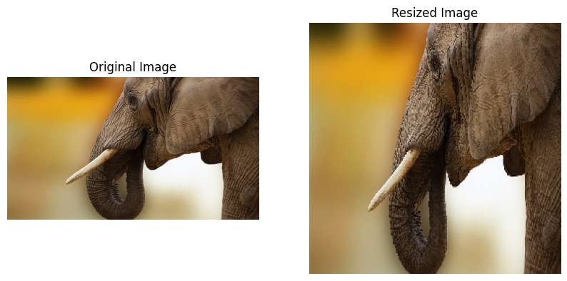**INFERENCE:**

The code resizes the image from its original size to 256x256 pixels using nearest neighbor interpolation and then displays both the original and resized images side by side.

**Histogram equalisation**

**CODE:**

import matplotlib.pyplot as plt

import numpy as np

import matplotlib.image as mpimg

def histogram_equalization(gray_img):

    hist, bins = np.histogram(gray_img.flatten(), bins=256, range=[0, 256])

    cdf = hist.cumsum()

    cdf_normalized = cdf * float(hist.max()) / cdf.max()

    cdf_m = np.ma.masked_equal(cdf, 0)

    cdf_m = (cdf_m - cdf_m.min()) * 255 / (cdf_m.max() - cdf_m.min())

    cdf = np.ma.filled(cdf_m, 0).astype('uint8')

    gray_img = gray_img.astype(np.uint8)

    img_equalized = cdf[gray_img]

    return img_equalized

img = mpimg.imread("C:/Users/yuval/Downloads/Elephant-Drawing.jpg")

if img.ndim == 3:

    gray_img = 0.2989 * img[:, :, 0] + 0.5870 * img[:, :, 1] + 0.1140 * img[:, :, 2]

else:

    gray_img =

img_equalized = histogram_equalization(gray_img)

fig, ax = plt.subplots(1, 2, figsize=(12, 6))

ax[0].imshow(gray_img, cmap='gray')

ax[0].set_title("Original Image")

ax[0].axis('off')

ax[1].imshow(img_equalized, cmap='gray')

ax[1].set_title("Equalized Image")

ax[1].axis('off')

plt.show()

fig, ax = plt.subplots(1, 2, figsize=(12, 6))

ax[0].hist(gray_img.flatten(), bins=256, range=[0, 256], color='gray')

ax[0].set_title("Original Histogram")

ax[1].hist(img_equalized.flatten(), bins=256, range=[0, 256], color='gray')

ax[1].set_title("Equalized Histogram")

plt.show()

**OUTPUT:**

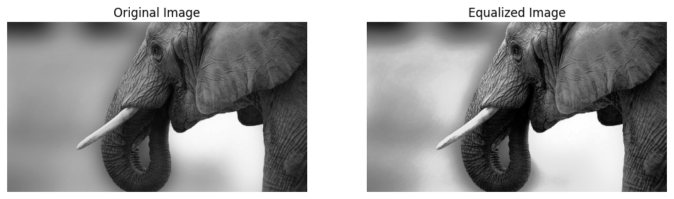 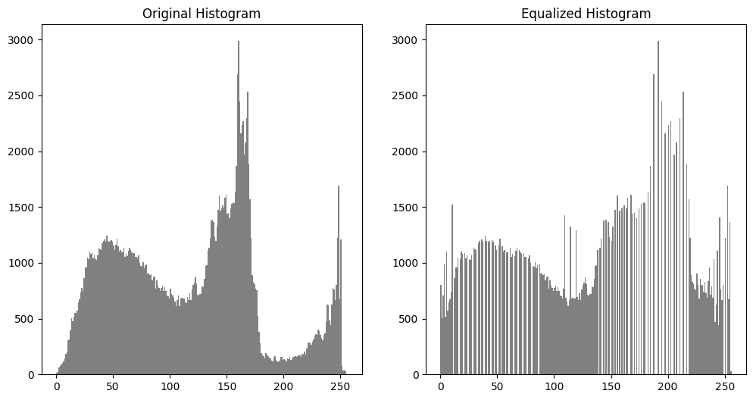

**INFERENCE:**

Histogram equalization improves image contrast by redistributing intensity values, spreads the histogram uniformly, and enhances visibility of details.

**Histogram equalisation manual**

**CODE:**

import matplotlib.pyplot as plt

import numpy as np

import matplotlib.image as mpimg

def histogram_equalization_manual(gray_img):

    hist, bins = np.histogram(gray_img.flatten(), bins=256, range=[0, 256])

    cdf = hist.cumsum()

    cdf_normalized = cdf * float(hist.max()) / cdf.max()

    cdf_m = np.ma.masked_equal(cdf, 0)

    cdf_m = (cdf_m - cdf_m.min()) * 255 / (cdf_m.max() - cdf_m.min())

    cdf = np.ma.filled(cdf_m, 0).astype('uint8')

    gray_img = gray_img.astype(np.uint8)

    img_equalized = cdf[gray_img]

    return img_equalized

img = mpimg.imread("C:/Users/yuval/Downloads/Elephant-Drawing.jpg")

if img.ndim == 3:

    gray_img = 0.2989 * img[:, :, 0] + 0.5870 * img[:, :, 1] + 0.1140 * img[:, :, 2]

else:

    gray_img = img

img_equalized = histogram_equalization_manual(gray_img)

fig, ax = plt.subplots(1, 2, figsize=(12, 6))

ax[0].imshow(gray_img, cmap='gray')

ax[0].set_title("Original Image")

ax[0].axis('off')

ax[1].imshow(img_equalized, cmap='gray')

ax[1].set_title("Equalized Image")

ax[1].axis('off')

plt.show()

fig, ax = plt.subplots(1, 2, figsize=(12, 6))

ax[0].hist(gray_img.flatten(), bins=256, range=[0, 256], color='gray')

ax[0].set_title("Original Histogram")

ax[1].hist(img_equalized.flatten(), bins=256, range=[0, 256], color='gray')

ax[1].set_title("Equalized Histogram")

plt.show()

**OUTPUT:**

 

**INFERENCE:**

Manual histogram equalization enhances image contrast by redistributing intensity values using the normalized CDF, making details clearer and spreading the histogram uniformly

**RESULT:**

The image was successfully read, converted to grayscale, resized, and its contrast was enhanced using both automatic and manual histogram equalization The results show improved image clarity, contrast, and uniformity in pixel intensity distribution, verified by visual outputs and histograms.

|  |  |
| --- | --- |
| **EX.NO:2**  **DATE:23/01/25** | **COLOR SPACES ON IMAGE** |

**AIM:**

The goal is to process an image by converting it to different color spaces (CMY, HSV), extracting individual channels (RGB, HSV), and displaying the results to understand how each channel contributes to the image.

**FUNCTIONS USED:**

1. **cv2.imread():**

Reads the image.

1. **cv2.cvtColor():**

Converts between color spaces (e.g., RGB, HSV).

1. **cv2.split():**

Splits image into channels.

**4) plt.imshow():**

Displays the image using matplotlib.

1. **plt.subplot():**

Creates subplots for side-by-side images.

**6) plt.axis('off'):**

Hides axes for clean display.

**ALGORITHM:**

1. **Load the Image:**

Read the image from a specified path using cv2.imread().

1. **Convert to RGB:**

Convert the image from BGR (OpenCV default) to RGB using cv2.cvtColor().

1. **Generate CMY Image:**

Invert the RGB values to generate the CMY (Cyan, Magenta, Yellow) representation by subtracting the RGB values from 255:

CMY=1−RGB

Display the CMY image using matplotlib.

1. **Extract RGB Channels:**

Extract individual Red, Green, and Blue channels using slicing:  
red_channel = img_rgb[:, :, 0],  
green_channel = img_rgb[:, :, 1],  
blue_channel = img_rgb[:, :, 2].

1. **Display RGB Channels:**

Display the Red, Green, and Blue channels separately using matplotlib with their respective color maps (Reds, Greens, Blues).

1. **Convert to HSV:**

Convert the image from RGB to HSV (Hue, Saturation, Value) using cv2.cvtColor().

1. **Display Original and HSV Image:**

Display the original RGB image and the HSV image side by side using matplotlib.

1. **Extract HSV Channels:**

Split the HSV image into individual Hue, Saturation, and Value channels using cv2.split().

1. **Display HSV Channels:**

Display the Hue, Saturation, and Value channels separately using matplotlib with color maps (hsv for Hue, gray for Saturation and Value).

**10)Generate Random Image:**

Create a random 500x500 image with random RGB values using numpy

blank_image[:,:]=[np.random.randint(0,255),np.random.randint(0,255),np.random.randint(0,255)]

Convert the image to RGB and display it using matplotlib.

1. **Adjust Layout:**

Use matplotlib.pyplot.tight_layout() to adjust layout and avoid subplot overlap.

1. **Show All Plots:**

Use plt.show() to render and display all images and plots.

**CODE:**

import cv2

import numpy as np

import matplotlib.pyplot as plt

img = cv2.imread("C:/Users/admin/Downloads/R.jpg")

img_rgb = cv2.cvtColor(img, cv2.COLOR_BGR2RGB)

plt.imshow(img_rgb)

plt.axis('off')

plt.show()

**OUTPUT:**

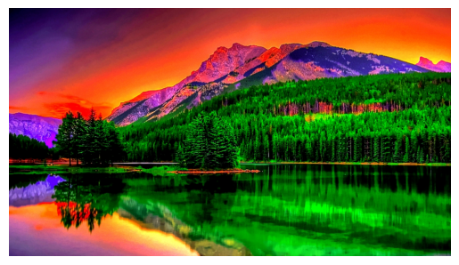

**INFERENCE:**

The code loads an image, converts it to RGB, and displays it using matplotlib**.**

**CODE:**

cmy = 1- img_rgb

plt.imshow(cmy)

plt.axis('off')

plt.show()

**OUTPUT:**

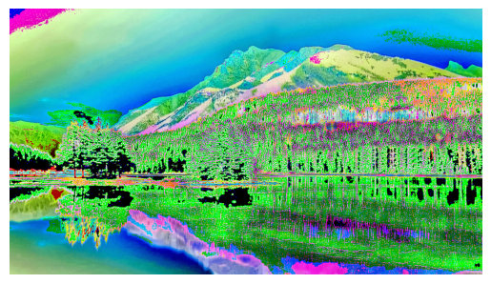

**INFERENCE:**

The code inverts the RGB image to create a CMY (Cyan, Magenta, Yellow) representation and displays it.

**CODE:**

import cv2

import matplotlib.pyplot as plt

image = cv2.imread("C:/Users/admin/Downloads/R.jpg")

image_rgb = cv2.cvtColor(image, cv2.COLOR_BGR2RGB)

red_channel = image_rgb[:, :, 0]

green_channel = image_rgb[:, :, 1]

blue_channel = image_rgb[:, :, 2]

plt.subplot(1, 3, 1)

plt.imshow(red_channel, cmap='Reds')

plt.title('Red Channel')

plt.axis('off')

plt.subplot(1, 3, 2)

plt.imshow(green_channel, cmap='Greens')

plt.title('Green Channel')

plt.axis('off')

plt.subplot(1, 3, 3)

plt.imshow(blue_channel, cmap='Blues')

plt.title('Blue Channel')

plt.axis('off')

plt.show()

**OUTPUT:**

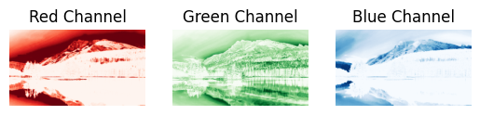

**INFERENCE:**

The code extracts and displays the Red, Green, and Blue channels of the image separately using color maps.

**HSV IMAGE:**

**CODE:**

import cv2

import matplotlib.pyplot as plt

image = cv2.imread("C:/Users/admin/Downloads/R.jpg")

hsv_image = cv2.cvtColor(image, cv2.COLOR_BGR2HSV)

plt.subplot(1, 2, 1)

plt.imshow(cv2.cvtColor(image, cv2.COLOR_BGR2RGB))

plt.title('Original Image')

plt.axis('off')

plt.subplot(1, 2, 2)

plt.imshow(cv2.cvtColor(hsv_image, cv2.COLOR_BGR2RGB))

plt.title('HSV Image')

plt.axis('off')

plt.show()

**OUTPUT:**

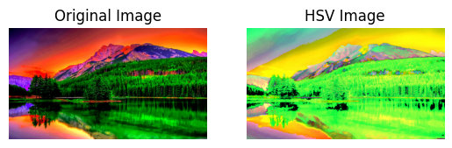

**INFERENCE:**

The code converts the image to HSV color space and displays both the original and HSV images side by side.

**CODE:**

import cv2

import matplotlib.pyplot as plt

image = cv2.imread(r"C:\Users\admin\Downloads\324673.jpg")

hsv_image = cv2.cvtColor(image, cv2.COLOR_BGR2HSV)

hue_channel, saturation_channel, value_channel = cv2.split(hsv_image)

plt.subplot(1, 3, 1)

plt.imshow(hue_channel, cmap='hsv')

plt.title('Hue Channel')

plt.axis('off')

plt.subplot(1, 3, 2)

plt.imshow(saturation_channel, cmap='gray')

plt.title('Saturation Channel')

plt.axis('off')

plt.subplot(1, 3, 3)

plt.imshow(value_channel, cmap='gray')

plt.title('Value Channel')

plt.axis('off')

plt.show()

**OUTPUT:**

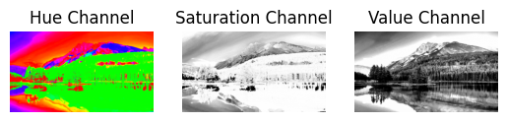

**INFERENCE:**

The code splits the HSV image into Hue, Saturation, and Value channels and displays them separately.

**CODE:**

import cv2

import numpy as np

import matplotlib.pyplot as plt

height, width = 500, 500

blank_image = np.zeros((height, width, 3), dtype=np.uint8)

blank_image[:, :] = [np.random.randint(0,255),np.random.randint(0,255) ,np.random.randint(0,255) ]

blank_image_rgb = cv2.cvtColor(blank_image, cv2.COLOR_BGR2RGB)

plt.imshow(blank_image_rgb)

plt.axis('off')

plt.show()

**OUTPUT:**



**INFERENCE:**

This code generates a blank image with random colors for each pixel and displays it using matplotlib.

**CONVERT INTO CMY IMAGE:**

**CODE:**

import cv2

import numpy as np

import matplotlib.pyplot as plt

img = cv2.imread(r"C:\Users\admin\Downloads\324673.jpg")

img_rgb = cv2.cvtColor(img, cv2.COLOR_BGR2RGB)

plt.imshow(img_rgb)

plt.axis('off')

plt.show()

**OUTPUT:**

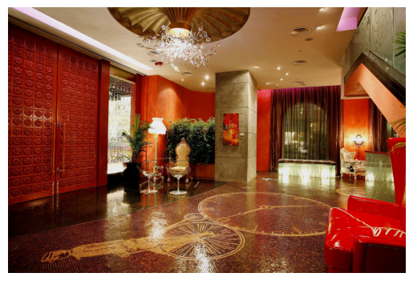

**INFERENCE:**

The code loads an image, converts it to RGB, and displays it using matplotlib.

**CODE:**

cmy = 1- img_rgb

plt.imshow(cmy)

plt.axis('off')

plt.show()

**OUTPUT:**

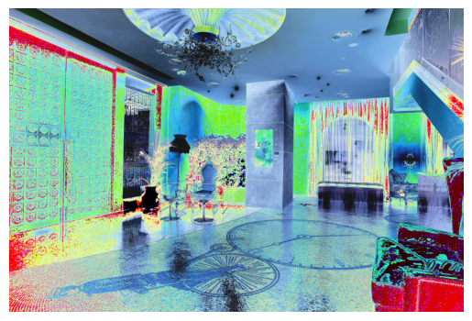

**INFERENCE:**

The code inverts the RGB image to create a CMY (Cyan, Magenta, Yellow) representation and displays it.

**CODE:**

red_channel = image_rgb[:, :, 0]

green_channel = image_rgb[:, :, 1]

blue_channel = image_rgb[:, :, 2]

plt.subplot(1, 3, 1)

plt.imshow(red_channel, cmap='Reds')

plt.title('Red Channel')

plt.axis('off')

plt.subplot(1, 3, 2)

plt.imshow(green_channel, cmap='Greens')

plt.title('Green Channel')

plt.axis('off')

plt.subplot(1, 3, 3)

plt.imshow(blue_channel, cmap='Blues')

plt.title('Blue Channel')

plt.axis('off')

plt.show()

**OUTPUT:**

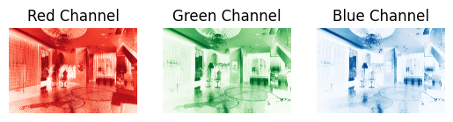

**INFERENCE:**

The code extracts and displays the Red, Green, and Blue channels of the image separately using color maps.

**HSV IMAGE:**

**CODE:**

import cv2

import matplotlib.pyplot as plt

image = cv2.imread(r"C:\Users\admin\Downloads\324673.jpg")

hsv_image = cv2.cvtColor(image, cv2.COLOR_BGR2HSV)

plt.subplot(1, 2, 1)

plt.imshow(cv2.cvtColor(image, cv2.COLOR_BGR2RGB))

plt.title('Original Image')

plt.axis('off')

plt.subplot(1, 2, 2)

plt.imshow(cv2.cvtColor(hsv_image, cv2.COLOR_BGR2RGB))

plt.title('HSV Image')

plt.axis('off')

plt.show()

**OUTPUT:**

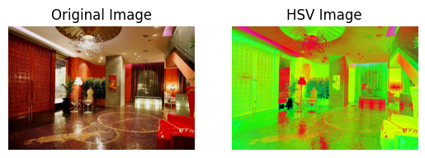

**INFERENCE:**

This code converts the image from BGR to HSV (Hue, Saturation, Value) color space and displays both the original and HSV images side by side.

**CODE:**

import cv2

import matplotlib.pyplot as plt

image = cv2.imread(r"C:\Users\admin\Downloads\324673.jpg")

hsv_image = cv2.cvtColor(image, cv2.COLOR_BGR2HSV)

hue_channel, saturation_channel, value_channel = cv2.split(hsv_image)

plt.subplot(1, 3, 1)

plt.imshow(hue_channel, cmap='hsv')

plt.title('Hue Channel')

plt.axis('off')

plt.subplot(1, 3, 2)

plt.imshow(saturation_channel, cmap='gray')

plt.title('Saturation Channel')

plt.axis('off')

plt.subplot(1, 3, 3)

plt.imshow(value_channel, cmap='gray')

plt.title('Value Channel')

plt.axis('off')

plt.show()

**OUTPUT:**

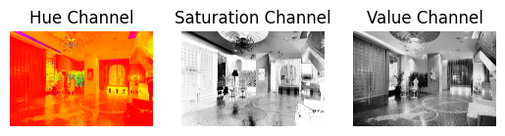

**INFERENCE:**

The code splits the HSV image into Hue, Saturation, and Value channels and displays them separately.

**RESULT:**

The code demonstrates how to convert an image between RGB, CMY, and HSV color spaces, extract and display individual channels (Red, Green, Blue, Hue, Saturation, Value), and generate random images for analysis. It helps visualize how each channel contributes to the image.

|  |  |
| --- | --- |
| EX.NO: 3  DATE:29/01/25 | SPATIAL IMAGE TRASFORMATIONS |

**AIM:**

To performs various image transformations (translation, rotation, scaling, shearing, and reflection) and visualizes the original and transformed images for comparison.

**FUNCTIONS USED:**

**1. matplotlib.pyplot.imshow()**

* **Purpose**: Displays an image in a Matplotlib plot.

**2. matplotlib.pyplot.axis()**

* **Purpose**: Toggles the display of axes in a plot (turning them on or off).

**3. cv2.imread()**

* **Purpose**: Reads an image from the specified file path.

**4. cv2.cvtColor()**

* **Purpose**: Converts an image from one color space to another (e.g., BGR to RGB).

**5. cv2.resize()**

* **Purpose**: Resizes an image to specified dimensions.

**6. numpy.zeros()**

* **Purpose**: Creates a new NumPy array filled with zeros, often used to initialize empty arrays or matrices.

**ALGORITHM:**

1. **Load Image**: image = cv2.imread(path)
2. **Convert to RGB**: img_rgb = cv2.cvtColor(image, cv2.COLOR_BGR2RGB)

**CODE SNIPPET:**

image = cv2.imread(r"C:\Users\admin\Downloads\dog.jpg")

img_rgb = cv2.cvtColor(image, cv2.COLOR_BGR2RGB)

plt.imshow(img_rgb)

plt.axis("off")

plt.show()

**OUTPUT:**

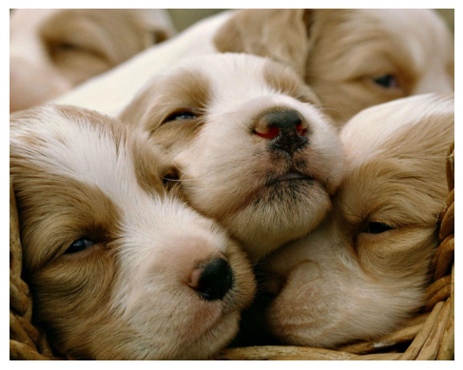

**TRANSLATION:**

**ALGORITHM:**

1. **Set Translation Parameters**: Define dx and dy.
2. **Get Dimensions**: Extract rows and cols from img_rgb.shape.
3. **Create Empty Image**: Initialize translated_image with zeros.
4. **Translate Image**: Shift pixels by dx and dy within bounds.
5. **Display Images**: Use plt.imshow() for both original and translated images.
6. **Show Plot**: Use plt.show() to display.

**CODE SNIPPET:**

dx, dy = 150, 100

rows, cols, _ = img_rgb.shape

translated_image = np.zeros_like(img_rgb)

for i in range(rows):

    for j in range(cols):

        if 0 <= i + dy < rows and 0 <= j + dx < cols:

            translated_image[i + dy, j + dx] = img_rgb[i, j]

plt.figure(figsize=(8, 4))

plt.subplot(1, 2, 1)

plt.imshow(img_rgb)

plt.title('Original Image')

plt.axis('off')

plt.subplot(1, 2, 2)

plt.imshow(translated_image)

plt.title(f'Translated Image (dx={dx}, dy={dy})')

plt.axis('off')

plt.show()

**OUTPUT:**

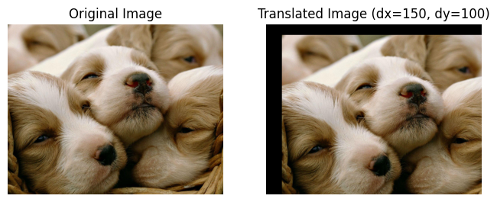

**INFERENCE:**

The code translates an image by shifting its pixels **right by 150** and **down by 100**, filling empty areas with black.

**ROTATION:**

**ALGORITHM:**

1) **Set Rotation Angle**: Convert angle to radians.

2) **Create Rotation Matrix**: Calculate using cosine and sine.

3) **Rotate Image**: Loop through pixels and apply the rotation matrix.

4) **Display**: Show original and rotated images with plt.imshow().

5) **Show Plot**: Use plt.show() to display.

**CODE SNIPPET:**

import math

def rotate_image(img_rgb, angle):

    rows, cols, _ = img_rgb.shape

    center = (cols // 2, rows // 2)

    angle_rad = math.radians(angle)

    rotation_matrix = np.array([

        [math.cos(angle_rad), -math.sin(angle_rad)],

        [math.sin(angle_rad), math.cos(angle_rad)])

    rotated_image = np.zeros_like(img_rgb)

    for i in range(rows):

        for j in range(cols):

            x_offset = j - center[0]

            y_offset = i - center[1]

            new_x = int(center[0] + rotation_matrix[0][0] * x_offset + rotation_matrix[0][1] * y_offset)

            new_y = int(center[1] + rotation_matrix[1][0] * x_offset + rotation_matrix[1][1] * y_offset)

            if 0 <= new_x < cols and 0 <= new_y < rows:

                rotated_image[new_y, new_x] = img_rgb[i, j]

    return rotated_image

rotated_image = rotate_image(img_rgb, 45)

plt.figure(figsize=(8, 4))

plt.subplot(1, 2, 1)

plt.imshow(img_rgb)

plt.title('Original Image')

plt.axis('off')

plt.subplot(1, 2, 2)

plt.imshow(rotated_image)

plt.title('Rotated Image (45 degrees)')

plt.axis('off')

plt.show()

**OUTPUT:**

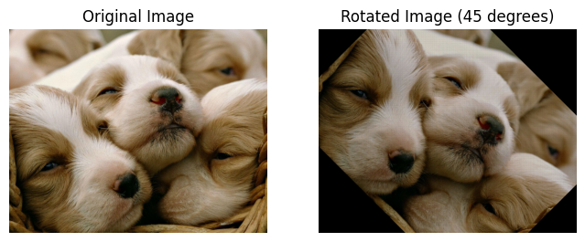

**INFERENCE:**

The code rotates an image by **45°** using a manually computed rotation matrix and maps pixels to new coordinates.

**SCALING:**

**ALGORITHM:**

1) **Set Scale Factor**: Calculate new image dimensions using the scale_factor.

2) **Create Scaled Image**: Initialize an empty array for the scaled image.

3) **Scale Image**: Map pixels from the original image to the scaled image using the scale factor.

4) **Display**: Show the original and scaled images side by side using plt.imshow().

5) **Show Plot**: Use plt.show() to display the plot.

**CODE SNIPPET:**

def scale_image(image, scale_factor):

original_height, original_width = image.shape[:2]

new_width = int(original_width * scale_factor)

new_height = int(original_height * scale_factor)

scaled_image = np.zeros((new_height, new_width, 3), dtype=image.dtype)

for y in range(new_height):

for x in range(new_width):

original_x = x / scale_factor

original_y = y / scale_factor

original_x = int(np.round(original_x))

original_y = int(np.round(original_y))

if 0 <= original_x < original_width and 0 <= original_y < original_height:

scaled_image[y, x] = image[original_y, original_x]

return scaled_image

output_image1 = scale_image(image,0.8)

output_image2 = scale_image(image,1.2)

fig,axes = plt.subplots(1,3,figsize = (10,5))

axes[0].imshow(image)

axes[0].set_title('Original image')

axes[1].imshow(output_image1)

axes[1].set_title('Scaled image(0.8x)')

axes[2].imshow(output_image2)

axes[2].set_title('Scaled image(1.2x)')

plt.tight_layout()

plt.show()

**OUTPUT:**

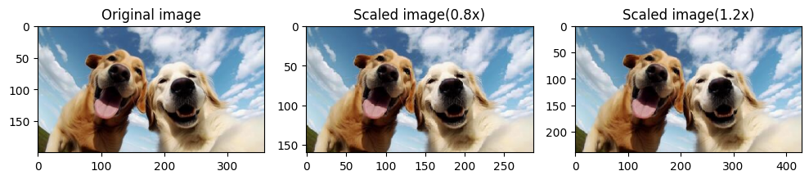

**INFERENCE:**

The code **scales an image** by a given factor (0.8x and 1.2x) using nearest-neighbor interpolation.

**SHEARING:**

**ALGORITHM:**

1. **Shear X-axis**: Shift pixels horizontally by multiplying row index with shear_factor.
2. **Shear Y-axis**: Shift pixels vertically by multiplying column index with shear_factor.
3. **Apply Shearing**: Create sheared images for both X and Y axes.
4. **Display**: Show the original, sheared X-axis, and sheared Y-axis images using plt.imshow().
5. **Show Plot**: Use plt.show() to display the plot.

**CODE SNIPPET:**

def shear_x(img_rgb, shear_factor):

    rows, cols, _ = image.shape

    sheared_image = np.zeros_like(img_rgb)

    for i in range(rows):

        for j in range(cols):

            new_j = int(j + shear_factor * i)

            if 0 <= new_j < cols:

                sheared_image[i, new_j] = img_rgb[i, j]

    return sheared_image

def shear_y(img_rgb, shear_factor):

    rows, cols, _ = image.shape

    sheared_image = np.zeros_like(img_rgb)

    for i in range(rows):

        for j in range(cols):

            new_i = int(i + shear_factor * j)

            if 0 <= new_i < rows:

                sheared_image[new_i, j] = img_rgb[i, j]

    return sheared_image

sheared_image_x = shear_x(img_rgb, 0.5)

sheared_image_y = shear_y(img_rgb, 0.5)

plt.figure(figsize=(10, 10))

plt.subplot(1, 3, 1)

plt.imshow(img_rgb)

plt.title('Original Image')

plt.axis('off')

plt.subplot(1, 3, 2)

plt.imshow(sheared_image_x)

plt.title('Sheared Image (X-axis)')

plt.axis('off')

plt.subplot(1, 3, 3)

plt.imshow(sheared_image_y)

plt.title('Sheared Image (Y-axis)')

plt.axis('off')

plt.show()

**OUTPUT:**

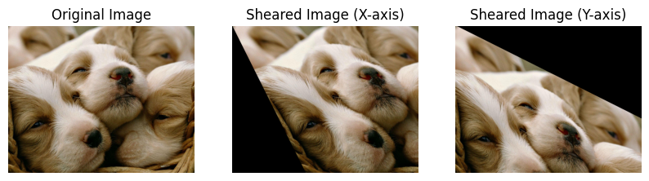

**INFERENCE:**

The code applies shearing transformation along the X-axisand Y-axis by shifting pixels based on a shear factor (0.5).

**REFLECTION:**

**ALGORITHM:**

1. **Reflect Vertically**: Flip pixels horizontally based on the column index.
2. **Reflect Horizontally**: Flip pixels vertically based on the row index.
3. **Reflect Origin**: Flip pixels both horizontally and vertically.
4. **Apply Reflections**: Create reflected images for vertical, horizontal, and origin flips.
5. **Display**: Show the original and reflected images side by side using plt.imshow().
6. **Show Plot**: Use plt.show() to display the plot.

Top of Form

Bottom of Form

**CODE SNIPPET:**

def reflect_vertical(img_rgb):

    rows, cols, _ = img_rgb.shape

    reflected_image = np.zeros_like(img_rgb)

    for i in range(rows):

        for j in range(cols):

            reflected_image[i, j] = img_rgb[i, cols - j - 1]

    return reflected_image

def reflect_horizontal(img_rgb):

    rows, cols, _ = img_rgb.shape

    reflected_image = np.zeros_like(img_rgb)

    for i in range(rows):

        for j in range(cols):

            reflected_image[i, j] = img_rgb[rows - i - 1, j]

    return reflected_image

def reflect_origin(img_rgb):

    rows, cols, _ = img_rgb.shape

    reflected_image = np.zeros_like(img_rgb)

    for i in range(rows):

        for j in range(cols):

            reflected_image[i, j] = img_rgb[rows - i - 1, cols - j - 1]

    return reflected_image

reflected_image_vertical = reflect_vertical(img_rgb)

reflected_image_horizontal = reflect_horizontal(img_rgb)

reflected_image_origin = reflect_origin(img_rgb)

plt.figure(figsize=(8, 4))

plt.subplot(2, 2, 1)

plt.imshow(img_rgb)

plt.title('Original Image')

plt.axis('off')

plt.subplot(2, 2, 2)

plt.imshow(reflected_image_vertical)

plt.title('Reflected Image (Vertical Axis)')

plt.axis('off')

plt.subplot(2, 2, 3)

plt.imshow(reflected_image_horizontal)

plt.title('Reflected Image (Horizontal Axis)')

plt.axis('off')

plt.subplot(2, 2, 4)

plt.imshow(reflected_image_origin)

plt.title('Reflected Image (Origin)')

plt.axis('off')

plt.show()

**OUTPUT:**

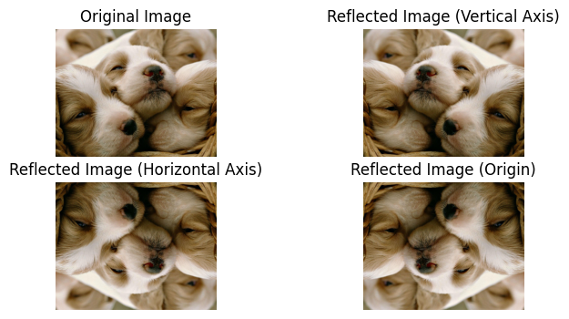

**INFERENCE:**

The code applies reflection transformations to an image along the vertical axis, horizontal axis, and origin (both axes) by swapping pixel positions.

**CODE SNIPPET:**

image = cv2.imread(r"C:\Users\admin\Downloads\elephant.jpg")

img_rgb = cv2.cvtColor(image, cv2.COLOR_BGR2RGB)

plt.imshow(img_rgb)

plt.axis("off")

plt.show()

**OUTPUT:**

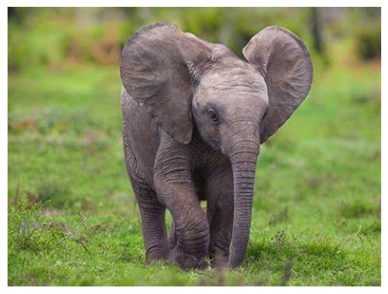

**CODE SNIPPET:**

dx, dy = 80, 50

rows, cols, _ = img_rgb.shape

translated_image = np.zeros_like(img_rgb)

for i in range(rows):

    for j in range(cols):

        if 0 <= i + dy < rows and 0 <= j + dx < cols:

            translated_image[i + dy, j + dx] = img_rgb[i, j]

plt.figure(figsize=(8, 4))

plt.subplot(1, 2, 1)

plt.imshow(img_rgb)

plt.title('Original Image')

plt.axis('off')

plt.subplot(1, 2, 2)

plt.imshow(translated_image)

plt.title(f'Translated Image (dx={dx}, dy={dy})')

plt.axis('off')

plt.show()

**OUTPUT:**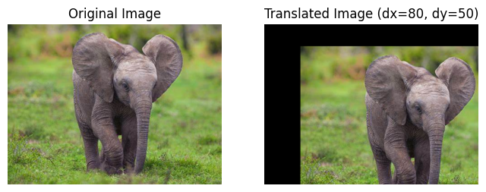

**CODE SNIPPET:**

def scale_image(image, scale_factor):

original_height, original_width = image.shape[:2]

new_width = int(original_width * scale_factor)

new_height = int(original_height * scale_factor)

scaled_image = np.zeros((new_height, new_width, 3), dtype=image.dtype)

for y in range(new_height):

for x in range(new_width):

original_x = x / scale_factor

original_y = y / scale_factor

original_x = int(np.round(original_x))

original_y = int(np.round(original_y))

if 0 <= original_x < original_width and 0 <= original_y < original_height:

scaled_image[y, x] = image[original_y, original_x]

return scaled_image

output_image1 = scale_image(image,0.8)

output_image2 = scale_image(image,1.2)

fig,axes = plt.subplots(1,3,figsize = (10,5))

axes[0].imshow(image)

axes[0].set_title('Original image')

axes[1].imshow(output_image1)

axes[1].set_title('Scaled image(0.8x)')

axes[2].imshow(output_image2)

axes[2].set_title('Scaled image(1.2x)')

plt.tight_layout()

plt.show()

**OUTPUT:**

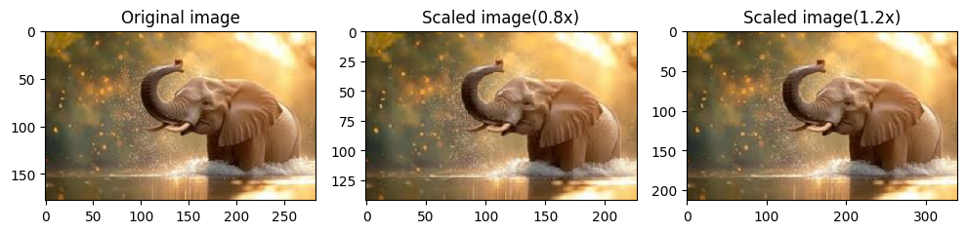

**CODE SNIPPET:**

def shear_x(img_rgb, shear_factor):

    rows, cols, _ = image.shape

    sheared_image = np.zeros_like(img_rgb)

    for i in range(rows):

        for j in range(cols):

            new_j = int(j + shear_factor * i)

            if 0 <= new_j < cols:

                sheared_image[i, new_j] = img_rgb[i, j]

    return sheared_image

def shear_y(img_rgb, shear_factor):

    rows, cols, _ = image.shape

    sheared_image = np.zeros_like(img_rgb)

    for i in range(rows):

        for j in range(cols):

            new_i = int(i + shear_factor * j)

            if 0 <= new_i < rows:

                sheared_image[new_i, j] = img_rgb[i, j]

    return sheared_image

sheared_image_x = shear_x(img_rgb, 0.5)

sheared_image_y = shear_y(img_rgb, 0.5)

plt.figure(figsize=(10, 10))

plt.subplot(1, 3, 1)

plt.imshow(img_rgb)

plt.title('Original Image')

plt.axis('off')

plt.subplot(1, 3, 2)

plt.imshow(sheared_image_x)

plt.title('Sheared Image (X-axis)')

plt.axis('off')

plt.subplot(1, 3, 3)

plt.imshow(sheared_image_y)

plt.title('Sheared Image (Y-axis)')

plt.axis('off')

plt.show()

**OUTPUT:**

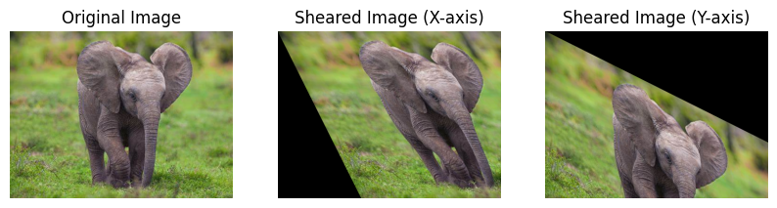

**CODE SNIPPET:**

import math

def rotate_image(img_rgb, angle):

    rows, cols, _ = img_rgb.shape

    center = (cols // 2, rows // 2)

    angle_rad = math.radians(angle)

    rotation_matrix = np.array([

        [math.cos(angle_rad), -math.sin(angle_rad)],

        [math.sin(angle_rad), math.cos(angle_rad)]

    ])

    rotated_image = np.zeros_like(img_rgb)

    for i in range(rows):

        for j in range(cols):

            x_offset = j - center[0]

            y_offset = i - center[1]

            new_x = int(center[0] + rotation_matrix[0][0] * x_offset + rotation_matrix[0][1] * y_offset)

            new_y = int(center[1] + rotation_matrix[1][0] * x_offset + rotation_matrix[1][1] * y_offset)

            if 0 <= new_x < cols and 0 <= new_y < rows:

                rotated_image[new_y, new_x] = img_rgb[i, j]

    return rotated_image

rotated_image = rotate_image(img_rgb, 45)

plt.figure(figsize=(8, 4))

plt.subplot(1, 2, 1)

plt.imshow(img_rgb)

plt.title('Original Image')

plt.axis('off')

plt.subplot(1, 2, 2)

plt.imshow(rotated_image)

plt.title('Rotated Image (45 degrees)')

plt.axis('off')

plt.show()

**OUTPUT:**

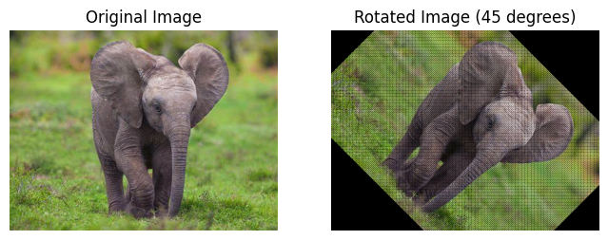

**CODE SNIPPET:**

def reflect_vertical(img_rgb):

    rows, cols, _ = img_rgb.shape

    reflected_image = np.zeros_like(img_rgb)

    for i in range(rows):

        for j in range(cols):

            reflected_image[i, j] = img_rgb[i, cols - j - 1]

    return reflected_image

def reflect_horizontal(img_rgb):

    rows, cols, _ = img_rgb.shape

    reflected_image = np.zeros_like(img_rgb)

    for i in range(rows):

        for j in range(cols):

            reflected_image[i, j] = img_rgb[rows - i - 1, j]

    return reflected_image

def reflect_origin(img_rgb):

    rows, cols, _ = img_rgb.shape

    reflected_image = np.zeros_like(img_rgb)

    for i in range(rows):

        for j in range(cols):

            reflected_image[i, j] = img_rgb[rows - i - 1, cols - j - 1]

    return reflected_image

reflected_image_vertical = reflect_vertical(img_rgb)

reflected_image_horizontal = reflect_horizontal(img_rgb)

reflected_image_origin = reflect_origin(img_rgb)

plt.figure(figsize=(8, 4))

plt.subplot(2, 2, 1)

plt.imshow(img_rgb)

plt.title('Original Image')

plt.axis('off')

plt.subplot(2, 2, 2)

plt.imshow(reflected_image_vertical)

plt.title('Reflected Image (Vertical Axis)')

plt.axis('off')

plt.subplot(2, 2, 3)

plt.imshow(reflected_image_horizontal)

plt.title('Reflected Image (Horizontal Axis)')

plt.axis('off')

plt.subplot(2, 2, 4)

plt.imshow(reflected_image_origin)

plt.title('Reflected Image (Origin)')

plt.axis('off')

plt.show()

**OUTPUT:**

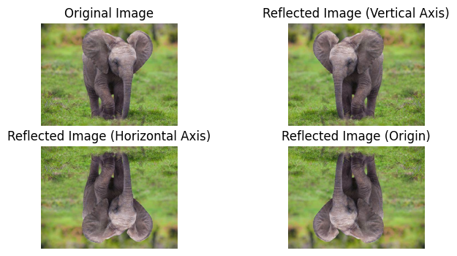

**RESULT:**

The code applies various image transformations (translation, rotation, scaling, shearing, and reflection) and displays the original and transformed images for comparison.

|  |  |
| --- | --- |
| **EX.NO:4**  **DATE:06/02/25** | Linear Filters |

**AIM:**

The aim is to showcase various image processing techniques for enhancing and analyzing images through transformations like contrast, smoothing, and sharpening.

**FUNCTIONS USED:**

1. **cv2.equalizeHist():** Equalizes the histogram of the grayscale image.
2. **cv2.add():** Adds a constant value to the image
3. **cv2.blur():** Applies a simple average filter for smoothing.
4. **cv2.filter2D()**: Applies a convolution with the sharpening kernel.
5. **cv2.medianBlur():** Applies a median filter for blurring.
6. **np.min(), np.max():** Find the minimum and maximum pixel values.
7. **np.dot():** Converts the image to grayscale (if needed).
8. **cv2.threshold():** Applies a global thresholding method.
9. **255 - image:** Computes the negative of the image.
10. **cv2.dft(), cv2.idft():** Apply the discrete Fourier transform and its inverse.
11. **np.fft.fftshift(), np.fft.ifftshift():** Shift the zero-frequency components to the center.

**CODE SNIPPET:**

import cv2

import matplotlib.pyplot as plt

image = cv2.imread(r"C:\Users\admin\Desktop\projecth\photohtml\car.jpg")

img_rgb = cv2.cvtColor(image, cv2.COLOR_BGR2RGB)

plt.imshow(img_rgb)

plt.axis("off")

plt.show()

**OUTPUT:**

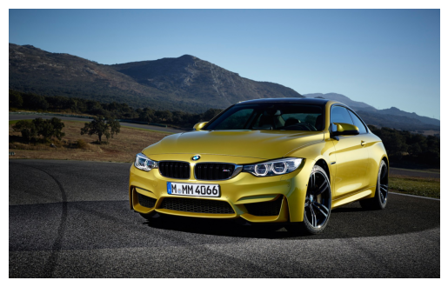

**HISTOGRAM EQUALISATION**

**ALGORITHM:**

1. Convert the image to grayscale.
2. Apply histogram equalization.
3. Display the original and equalized histograms and images.

**CODE SNIPPET:**

import numpy as np

image = cv2.imread(r"C:\Users\admin\Desktop\projecth\photohtml\car.jpg", cv2.IMREAD_GRAYSCALE)

equalized_image = cv2.equalizeHist(image)

plt.figure(figsize=(8, 4))

plt.subplot(1, 2, 1)

plt.hist(image.ravel(), bins=256, range=[0, 256], color='black')

plt.title('Original Image Histogram')

plt.xlabel('Pixel Intensity')

plt.ylabel('Frequency')

plt.subplot(1, 2, 2)

plt.hist(equalized_image.ravel(), bins=256, range=[0, 256], color='black')

plt.title('Equalized Image Histogram')

plt.xlabel('Pixel Intensity')

plt.ylabel('Frequency')

plt.show()

plt.figure(figsize=(8, 4))

plt.subplot(1, 2, 1)

plt.imshow(image, cmap='gray')

plt.title('Original Image')

plt.axis('off')

plt.subplot(1, 2, 2)

plt.imshow(equalized_image, cmap='gray')

plt.title('Equalized Image')

plt.axis('off')

plt.show()

**OUTPUT:**

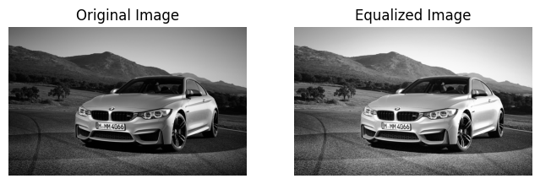

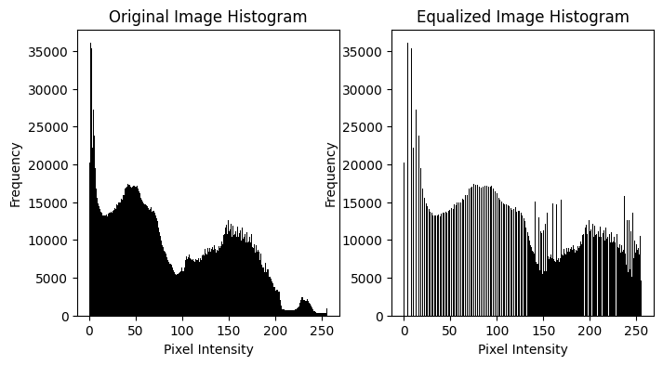

**INFERENCES:**

Histogram equalization improves contrast in images, making features more distinct. It helps in improving visibility in both dark and bright regions of the image.

**HISTOGRAM SHIFTING:**

**ALGORITHM:**

1. Read the grayscale image.
2. Add a constant value to each pixel of the image.
3. Display the original and shifted histograms and images.

**CODE SNIPPET:**

image = cv2.imread(r"C:\Users\yuval\Downloads\car.jpg", cv2.IMREAD_GRAYSCALE)

shift_value = 30

shifted_image = np.zeros_like(image)

rows, cols = image.shape

for i in range(rows):

for j in range(cols):

shifted_image[i, j] = min(image[i, j] + shift_value, 255)

plt.figure(figsize=(10, 5))

plt.subplot(1, 2, 1)

plt.imshow(image, cmap='gray')

plt.title('Original Image')

plt.axis('off')

plt.subplot(1, 2, 2)

plt.imshow(shifted_image, cmap='gray')

plt.title(f'Shifted Image (k={shift_value})')

plt.axis('off')

plt.show()

original_hist = [0] * 256

shifted_hist = [0] * 256

for i in range(rows):

for j in range(cols):

original_hist[image[i, j]] += 1

shifted_hist[shifted_image[i, j]] += 1

plt.figure(figsize=(8, 4))

plt.subplot(1, 2, 1)

plt.bar(range(256), original_hist, color='black')

plt.title('Original Image Histogram')

plt.xlabel('Pixel Intensity')

plt.ylabel('Frequency')

plt.subplot(1, 2, 2)

plt.bar(range(256), shifted_hist, color='black')

plt.title('Shifted Image Histogram')

plt.xlabel('Pixel Intensity')

plt.ylabel('Frequency')

plt.show()

**OUTPUT:**

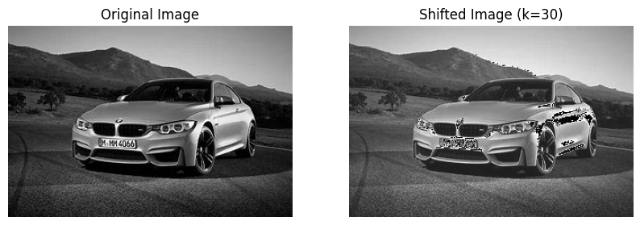

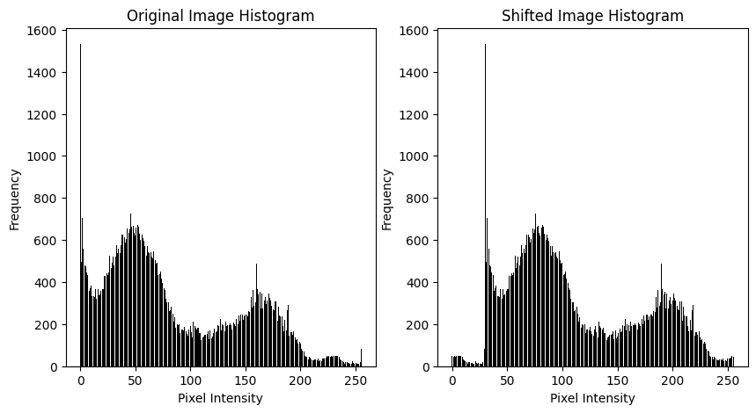

**INFERENCES:**

Histogram shifting affects the brightness of the image. It results in a change in the image's pixel intensity distribution.

**IMAGE SMOOTHING:**

**ALGORITHM:**

1. Convert the image to RGB.
2. Apply a blur filter to smooth the image.
3. Display the original and smoothed images.

**CODE SNIPPET:**

def manual_blur(img):

blurred = np.zeros_like(img)

for i in range(1, rows - 1):

for j in range(1, cols - 1):

if channels == 1:

blurred[i, j] = np.mean(img[i-1:i+2, j-1:j+2])

else:

for c in range(channels):

blurred[i, j, c] = np.mean(img[i-1:i+2, j-1:j+2, c])

return blurred

smoothed_image = manual_blur(image)

smoothed_image_rgb = smoothed_image.copy() if channels == 1 else np.zeros_like(smoothed_image)

if channels > 1:

for i in range(rows):

for j in range(cols):

smoothed_image_rgb[i, j] = smoothed_image[i, j][::-1]

plt.figure(figsize=(8, 4))

plt.subplot(1, 2, 1)

plt.imshow(image_rgb, cmap='gray' if channels == 1 else None)

plt.title('Original Image')

plt.axis('off')

plt.subplot(1, 2, 2)

plt.imshow(smoothed_image_rgb, cmap='gray' if channels == 1 else None)

plt.title('Smoothed Image')

plt.axis('off')

plt.show()

def plot_histogram(image, title):

plt.hist(image.ravel(), bins=256, range=[0, 256], color='black')

plt.title(title)

plt.xlabel('Pixel Intensity')

plt.ylabel('Frequency')

plt.figure(figsize=(8, 4))

plt.subplot(1, 2, 1)

plot_histogram(smoothed_image_rgb, 'Original Image Histogram')

plt.subplot(1, 2, 2)

plot_histogram(smoothed_image_rgb, 'Smoothed Image Histogram')

plt.tight_layout()

plt.show()

**OUTPUT:**

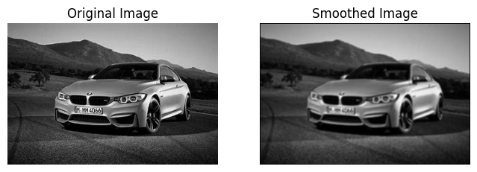

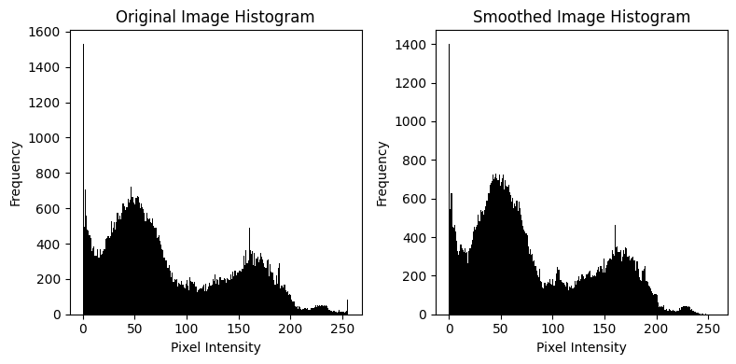

**INFERENCES:**

Smoothing reduces high-frequency noise but can blur important details. The image becomes softer, with reduced sharpness in edges.

**SHARPENED IMAGE:**

**ALGORITHM:**

1. Convert the image to RGB.
2. Apply a sharpening kernel using convolution.
3. Display the original and sharpened images.

**CODE SNIPPET:**

image_rgb = cv2.cvtColor(image, cv2.COLOR_BGR2RGB)

sharpening_kernel = np.array([[ 0, -1,  0],

                               [-1,  5, -1],

                               [ 0, -1,  0]])

sharpened_image = cv2.filter2D(image, -1, sharpening_kernel)

sharpened_image_rgb = cv2.cvtColor(sharpened_image, cv2.COLOR_BGR2RGB)

plt.figure(figsize=(10, 5))

plt.subplot(1, 2, 1)

plt.imshow(image_rgb)

plt.title('Original Image')

plt.axis('off')

plt.subplot(1, 2, 2)

plt.imshow(sharpened_image_rgb)

plt.title('Sharpened Image')

plt.axis('off')

plt.show()

plt.figure(figsize=(8, 4))

plt.subplot(1, 2, 1)

plt.hist(image.ravel(), bins=256, range=[0, 256], color='black')

plt.title('Original Image Histogram')

plt.xlabel('Pixel Intensity')

plt.ylabel('Frequency')

plt.subplot(1, 2, 2)

plt.hist(sharpened_image_rgb.ravel(), bins=256, range=[0, 256], color='black')

plt.title('Sharpened Image Histogram')

plt.xlabel('Pixel Intensity')

plt.ylabel('Frequency')

plt.tight_layout()

plt.show()

**OUTPUT:**

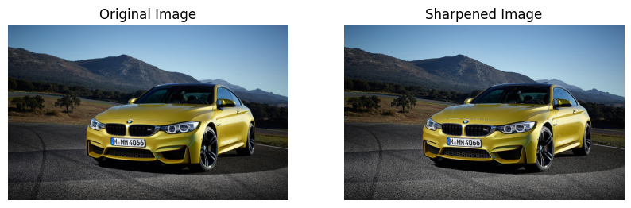

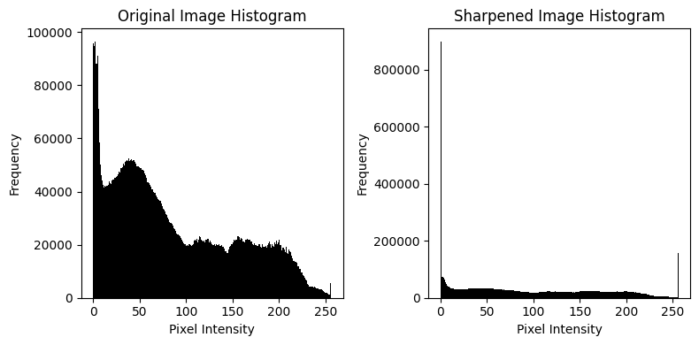

**INFERENCES:**

Sharpening enhances the edges and makes the image look clearer. It amplifies the high-frequency components (edges) of the image.

**BLURED IMAGE:**

**ALGORITHM:**

1. Convert the image to grayscale.
2. Apply a median blur to the image.
3. Display the original and blurred images.

**CODE SNIPPET:**

def manual_median_blur(image, ksize=5):

if len(image.shape) == 2:

image = image[:, :, np.newaxis]

rows, cols, channels = image.shape

pad = ksize // 2

padded_img = np.pad(image, ((pad, pad), (pad, pad), (0, 0)), mode='constant', constant_values=0)

blurred = np.zeros_like(image)

for i in range(rows):

for j in range(cols):

for c in range(channels):

neighborhood = padded_img[i:i+ksize, j:j+ksize, c]

blurred[i, j, c] = np.median(neighborhood)

return blurred

median_blurred_image = manual_median_blur(image, 5)

plt.figure(figsize=(10, 5))

plt.subplot(1, 2, 1)

plt.imshow(image)

plt.title('Original Image )

plt.axis('off')

plt.subplot(1, 2, 2)

plt.imshow(median_blurred_image)

plt.title('Median Blurred Image (RGB)')

plt.axis('off')

plt.show()

plt.figure(figsize=(10, 5))

plt.subplot(1, 2, 1)

plt.hist(image.ravel(), bins=256, range=[0, 256], color='black')

plt.title('Original Image Histogram')

plt.xlabel('Pixel Intensity')

plt.ylabel('Frequency')

plt.subplot(1, 2, 2)

plt.hist(median_blurred_image.ravel(), bins=256, range=[0, 256], color='black')

plt.title('Blurred Image Histogram')

plt.xlabel('Pixel Intensity')

plt.ylabel('Frequency')

plt.tight_layout

plt.show()

**OUTPUT:**

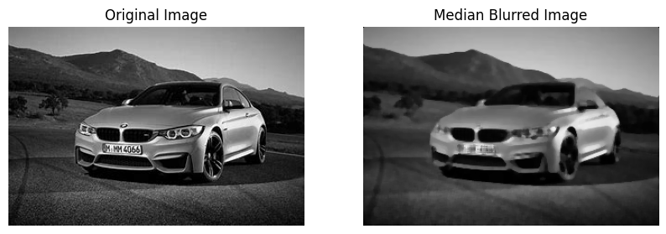

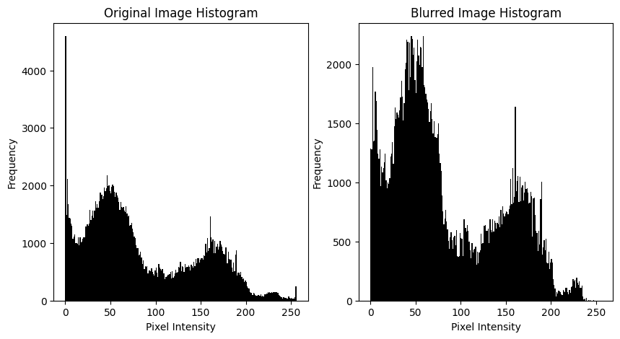

**INFERENCES:**

The median blur is effective in removing noise while maintaining the edges. The image becomes smoother with reduced sharp transitions.

**IMAGE STRETCHING:**

**ALGORITHM:**

1. Convert the image to grayscale.
2. Calculate the min and max pixel values.
3. Stretch the pixel values to the full range (0-255).
4. Display the original and stretched images.

**CODE SNIPPET:**

from PIL import Image

image = Image.open(r"C:\Users\admin\Desktop\projecth\photohtml\car.jpg")

image = np.array(image)

if image.ndim == 3:

    image = np.dot(image[... , :3], [0.2989, 0.5870, 0.1140])

min_val = np.min(image)

max_val = np.max(image)

stretched_image = 255 * (image - min_val) / (max_val - min_val)

stretched_image = np.uint8(stretched_image)

fig, axs = plt.subplots(1, 4, figsize=(18, 6))

axs[0].imshow(image, cmap='gray')

axs[0].set_title("Original Image")

axs[0].axis('off')

axs[1].hist(image.ravel(), bins=256, color='gray', alpha=0.7)

axs[1].set_title("Original Image Histogram")

axs[1].set_xlim(0, 255)

axs[2].imshow(stretched_image, cmap='gray')

axs[2].set_title("Stretched Image")

axs[2].axis('off')

axs[3].hist(stretched_image.ravel(), bins=256, color='gray', alpha=0.7)

axs[3].set_title("Stretched Image Histogram")

axs[3].set_xlim(0, 255)

plt.tight_layout()

plt.show()

**OUTPUT:**

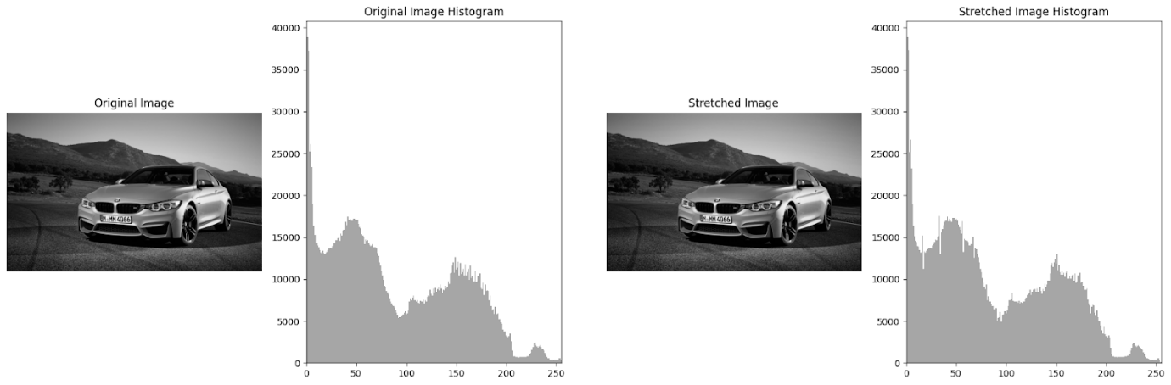

**INFERENCES:**

Image stretching improves the contrast by using the full range of pixel intensities. The image becomes more visually distinct, with clearer features.

**THRESHOLD IMAGE:**

**ALGORITHM:**

1. Read the image in grayscale.
2. Apply a global threshold to convert it into a binary image.
3. Display the original and thresholded images.

**CODE SNIPPET:**

image = cv2.imread(r"C:\Users\yuval\Downloads\car.jpg", cv2.IMREAD_GRAYSCALE)

_, global_thresh = cv2.threshold(image, 127, 255, cv2.THRESH_BINARY)

plt.figure(figsize=(8, 4))

plt.subplot(1, 2, 1)

plt.imshow(image, cmap='gray')

plt.title('Original Image')

plt.axis('off')

plt.subplot(1, 2, 2)

plt.imshow(global_thresh , cmap='gray')

plt.title('Threshold Image')

plt.axis('off')

plt.show()

plt.figure(figsize=(8, 4))

plt.subplot(1, 2, 1)

plt.hist(image.ravel(), bins=256, range=[0, 256], color='black')

plt.title('Original Image Histogram')

plt.xlabel('Pixel Intensity')

plt.ylabel('Frequency')

plt.subplot(1, 2, 2)

plt.hist(global_thresh .ravel(), bins=256, range=[0, 256], color='black')

plt.title('threshold Image Histogram')

plt.xlabel('Pixel Intensity')

plt.ylabel('Frequency')

plt.tight_layout()

plt.show()

**OUTPUT:**

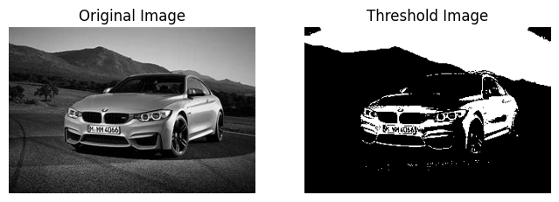

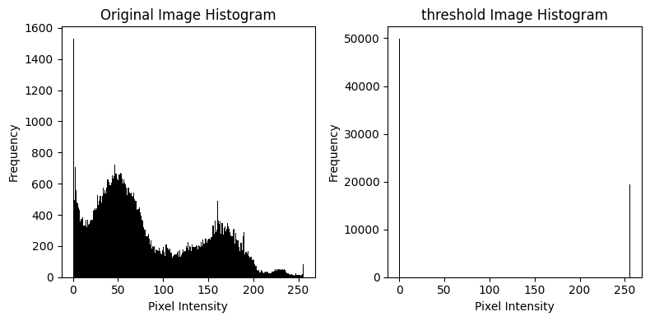

**INFERENCES:**

Thresholding segments the image into foreground and background. It simplifies the image, making objects stand out more clearly.

**NEGATIVE IMAGE:**

**ALGORITHM:**

1. Read the image.
2. Subtract the pixel values from 255.
3. Display the original and negative images.

**CODE SNIPPET:**

negative_image = 255 - image

plt.figure(figsize=(8, 4))

plt.subplot(1, 2, 1)

plt.imshow(image, cmap='gray')

plt.title('Original Image')

plt.axis('off')

plt.subplot(1, 2, 2)

plt.imshow(negative_image, cmap='gray')

plt.title('Negative Image')

plt.axis('off')

plt.show()

plt.figure(figsize=(8, 4))

plt.subplot(1, 2, 1)

plt.hist(image.ravel(), bins=256, range=[0, 256], color='black')

plt.title('Original Image Histogram')

plt.xlabel('Pixel Intensity')

plt.ylabel('Frequency')

plt.subplot(1, 2, 2)

plt.hist(negative_image .ravel(), bins=256, range=[0, 256], color='black')

plt.title('Negative Image Histogram')

plt.xlabel('Pixel Intensity')

plt.ylabel('Frequency')

plt.tight_layout()

plt.show()

**OUTPUT:**

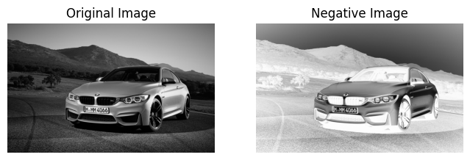

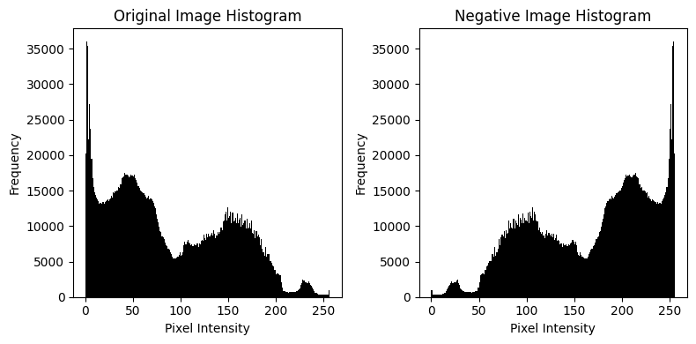

**INFERENCES:**

The negative image is a visual inverse, where dark pixels become light and vice versa. This is often used for artistic effects or highlighting features.

**DFT:**

**ALGORITHM:**

1. Convert the image to a float32 format.
2. Apply DFT to get the frequency components.
3. Compute the magnitude spectrum.
4. Apply the inverse DFT to reconstruct the image.
5. Display the original, magnitude spectrum, and reconstructed images.

**CODE SNIPPET:**

image_float32 = np.float32(image)

dft = cv2.dft(image_float32, flags=cv2.DFT_COMPLEX_OUTPUT)

dft_shift = np.fft.fftshift(dft)

magnitude_spectrum = cv2.magnitude(dft_shift[:, :, 0], dft_shift[:, :, 1])

magnitude_spectrum = np.log(magnitude_spectrum + 1)

idft_shift = np.fft.ifftshift(dft_shift)

idft = cv2.idft(idft_shift)

idft_image = cv2.magnitude(idft[:, :, 0], idft[:, :, 1])

plt.figure(figsize=(8, 4))

plt.subplot(1, 2, 1)

plt.imshow(image, cmap='gray')

plt.title('Original Image')

plt.axis('off')

plt.subplot(1, 2, 2)

plt.imshow(magnitude_spectrum, cmap='gray')

plt.title('Magnitude Spectrum')

plt.axis('off')

plt.show()

plt.figure(figsize=(8, 4))

plt.imshow(idft_image, cmap='gray')

plt.title('Reconstructed Image from DFT')

plt.axis('off')

plt.show()

plt.figure(figsize=(8, 4))

plt.subplot(1, 2, 1)

plt.hist(image.ravel(), bins=256, range=[0, 256], color='black')

plt.title('Original Image Histogram')

plt.xlabel('Pixel Intensity')

plt.ylabel('Frequency')

plt.subplot(1, 2, 2)

plt.hist(idft_image.ravel(), bins=256, range=[0, 256], color='black')

plt.title('idft Image Histogram')

plt.xlabel('Pixel Intensity')

plt.ylabel('Frequency')

plt.tight_layout()

plt.show()

**OUTPUT:**

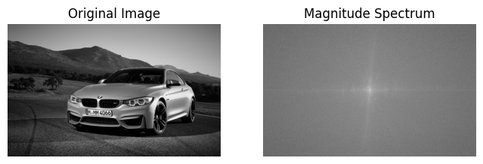 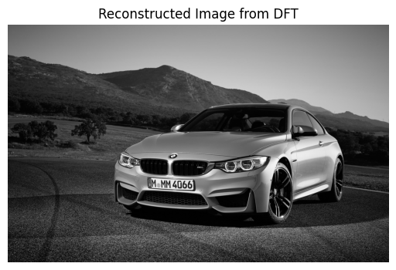

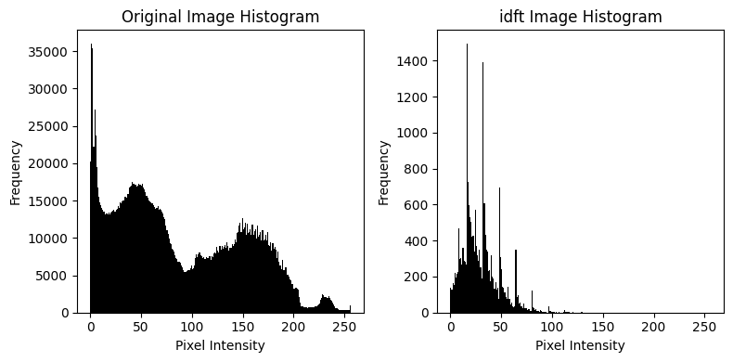

**INFERENCES:**

The magnitude spectrum shows the frequency components, with low frequencies in the center. The inverse DFT reconstructs the image from its frequency domain representation.

**RESULT:**

The images show improved features, reduced noise, and enhanced details through various processing techniques.

|  |  |
| --- | --- |
| **EX.NO: 5**  **DATE:13/02/25** | **IMAGE RESTORATION** |

**AIM:**

To analyze the effects of different types of noise on an image and apply various filtering techniques, including edge detection using Sobel operators, to enhance image quality and extract features.

**FUNCTIONS USED:**

1. **Image Processing & Display:**
   * cv2.imread(), cv2.cvtColor(), plt.imshow(), plt.axis(), plt.show(), plt.hist()
2. **Noise Addition:**
   * np.random.normal(), np.random.rayleigh(), np.random.gamma(), np.random.exponential(), np.random.uniform(), np.random.rand(), np.clip()
3. **Filtering Techniques:**
   * **Mean Filter:** np.mean()
   * **Gaussian Filter:** np.exp(), np.mgrid(), np.sum()
   * **Median Filter:** np.median()
   * **Bilateral Filter:** cv2.bilateralFilter()
   * **Wiener Filter:** scipy.signal.wiener()
4. **Edge Detection (Sobel Operators):**
   * **Convolution:** np.pad(), np.sum(), np.sqrt(), np.clip()

**CODE SNIPPET:**

import cv2

import matplotlib.pyplot as plt

import numpy as np

image = cv2.imread(r"C:\Users\yuval\Downloads\img.jpg")

image = cv2.cvtColor(image, cv2.COLOR_BGR2GRAY)

plt.imshow(image,cmap='gray')

plt.axis("off")

plt.show()

**OUTPUT:**

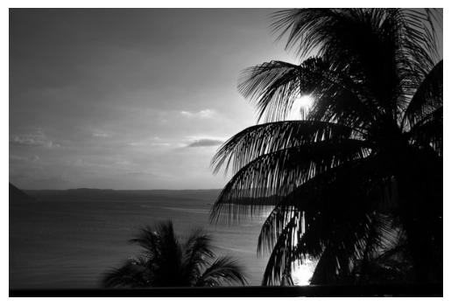

**ADDING DIFFERENT TYPES OF NOISE:**

**ALGORITHM:**

1. Read and convert the image to grayscale.
2. Generate different types of noise.
3. Add the noise to the image and ensure pixel values remain in the valid range.
4. Display original and noisy images along with histograms.

**CODE SNIPPET:**

def add_gaussian_noise(image):

    row, col = image.shape

    mean = 0

    sigma = 25

    gauss = np.random.normal(mean, sigma, (row, col))

    noisy = np.clip(image + gauss, 0, 255)

    return noisy.astype(np.uint8)

def add_rayleigh_noise(image):

    row, col = image.shape

    sigma = 25

    rayleigh = np.random.rayleigh(sigma, (row, col))

    noisy = np.clip(image + rayleigh, 0, 255)

    return noisy.astype(np.uint8)

def add_gamma_noise(image):

    row, col = image.shape

    shape = 2

    scale = 25

    gamma = np.random.gamma(shape, scale, (row, col))

    noisy = np.clip(image + gamma, 0, 255)

    return noisy.astype(np.uint8)

def add_exponential_noise(image):

    row, col = image.shape

    scale = 25

    exp_noise = np.random.exponential(scale, (row, col))

    noisy = np.clip(image + exp_noise, 0, 255)

    return noisy.astype(np.uint8)

def add_uniform_noise(image):

    row, col = image.shape

    low = -25

    high = 25

    uniform = np.random.uniform(low, high, (row, col))

    noisy = np.clip(image + uniform, 0, 255)

    return noisy.astype(np.uint8)

def add_impulse_noise(image):

    row, col = image.shape

    output = np.copy(image)

    prob = 0.1

    black = np.random.rand(row, col) < prob / 2

    white = np.random.rand(row, col) < prob / 2

    output[black] = 0

    output[white] = 255

    return output

gaussian_noisy = add_gaussian_noise(image)

rayleigh_noisy = add_rayleigh_noise(image)

gamma_noisy = add_gamma_noise(image)

exponential_noisy = add_exponential_noise(image)

uniform_noisy = add_uniform_noise(image)

impulse_noisy = add_impulse_noise(image)

fig, axes = plt.subplots(7, 2, figsize=(14, 26))

titles = ["Original", "Gaussian Noise", "Rayleigh Noise",

          "Gamma Noise", "Uniform Noise", "Salt & Pepper Noise", "Exponential Noise"]

images = [image, gaussian_noisy, rayleigh_noisy,

          gamma_noisy, uniform_noisy, impulse_noisy, exponential_noisy]

for i in range(7):

    axes[i][0].imshow(images[i], cmap="gray")

    axes[i][0].set_title(titles[i])

    axes[i][0].axis("off")

    axes[i][1].hist(images[i].ravel(),bins = 256,color = 'black',alpha = 0.6)

    axes[i][1].set_title(f"Histogram of {titles[i]} image")

plt.tight_layout()

plt.show()

**OUTPUT:**

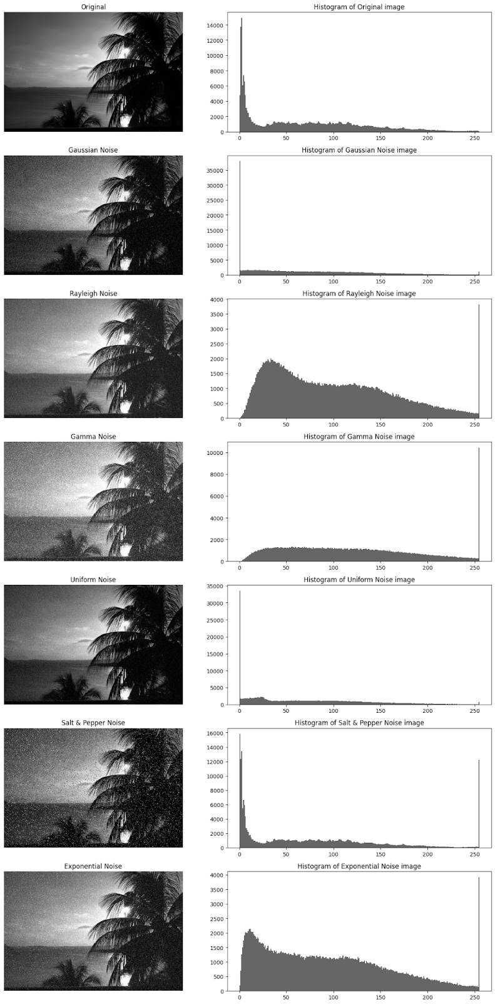

**INFERENCE:**

* Each noise affects the image differently:
  + Gaussian Noise: Common in natural images due to sensor noise.
  + Rayleigh Noise: Skews toward bright pixels.
  + Gamma Noise: Affects contrast.
  + Exponential Noise: Introduces strong variations.
  + Uniform Noise: Random intensity shifts.
  + Impulse Noise (Salt & Pepper): Introduces white and black pixels randomly.
* The histogram shows how pixel intensity distribution is affected by each noise.

**IMAGE FILTERING:**

**ALGORITHM:**

1. Apply different filters manually:
   * Mean Filter: Averages pixel values in a window.
   * Gaussian Filter: Uses a weighted average based on a Gaussian distribution.
   * Median Filter: Replaces each pixel with the median value in its neighborhood.
   * Bilateral Filter: Averages while preserving edges.
2. Display results and histograms.

**CODE SNIPPET:**

from scipy.signal import wiener

image = cv2.imread(r"C:\Users\yuval\Downloads\img.jpg", cv2.IMREAD_GRAYSCALE)

def manual_mean_filter(image, kernel_size=5):

    pad = kernel_size // 2

    padded_image = np.pad(image, pad, mode='edge')

    filtered_image = np.zeros_like(image)

    for i in range(image.shape[0]):

        for j in range(image.shape[1]):

            region = padded_image[i:i+kernel_size, j:j+kernel_size]

            filtered_image[i, j] = np.mean(region)

    return filtered_image.astype(np.uint8)

def manual_gaussian_filter(image, kernel_size=5, sigma=1):

    pad = kernel_size // 2

    x, y = np.mgrid[-pad:pad+1, -pad:pad+1]

    gaussian_kernel = np.exp(-(x**2 + y**2) / (2 * sigma**2))

    gaussian_kernel /= gaussian_kernel.sum()

    padded_image = np.pad(image, pad, mode='edge')

    filtered_image = np.zeros_like(image)

    for i in range(image.shape[0]):

        for j in range(image.shape[1]):

            region = padded_image[i:i+kernel_size, j:j+kernel_size]

            filtered_image[i, j] = np.sum(region * gaussian_kernel)

    return filtered_image.astype(np.uint8)

def manual_median_filter(image, kernel_size=5):

    pad = kernel_size // 2

    padded_image = np.pad(image, pad, mode='edge')

    filtered_image = np.zeros_like(image)

    for i in range(image.shape[0]):

        for j in range(image.shape[1]):

            region = padded_image[i:i+kernel_size, j:j+kernel_size]

            filtered_image[i, j] = np.median(region)

    return filtered_image.astype(np.uint8)

def manual_bilateral_filter(image, d=9, sigma_color=75, sigma_space=75):

    return cv2.bilateralFilter(image, d, sigma_color, sigma_space)

titles = ["Original Noisy", "Mean Filter", "Gaussian Filter", "Median Filter", "Bilateral Filter"]

images = [image, mean_filtered, gaussian_filtered, median_filtered, bilateral_filtered]

fig, axes = plt.subplots(5, 2, figsize=(14, 15))

for i in range(5):

    axes[i, 0].imshow(images[i], cmap="gray")

    axes[i, 0].set_title(titles[i])

    axes[i, 0].axis("off")

    axes[i, 1].hist(images[i].ravel(), bins=256, color='black', alpha=0.7)

    axes[i, 1].set_title(f"Histogram of {titles[i]} Image")

plt.tight_layout()

plt.show()

**OUTPUT:**

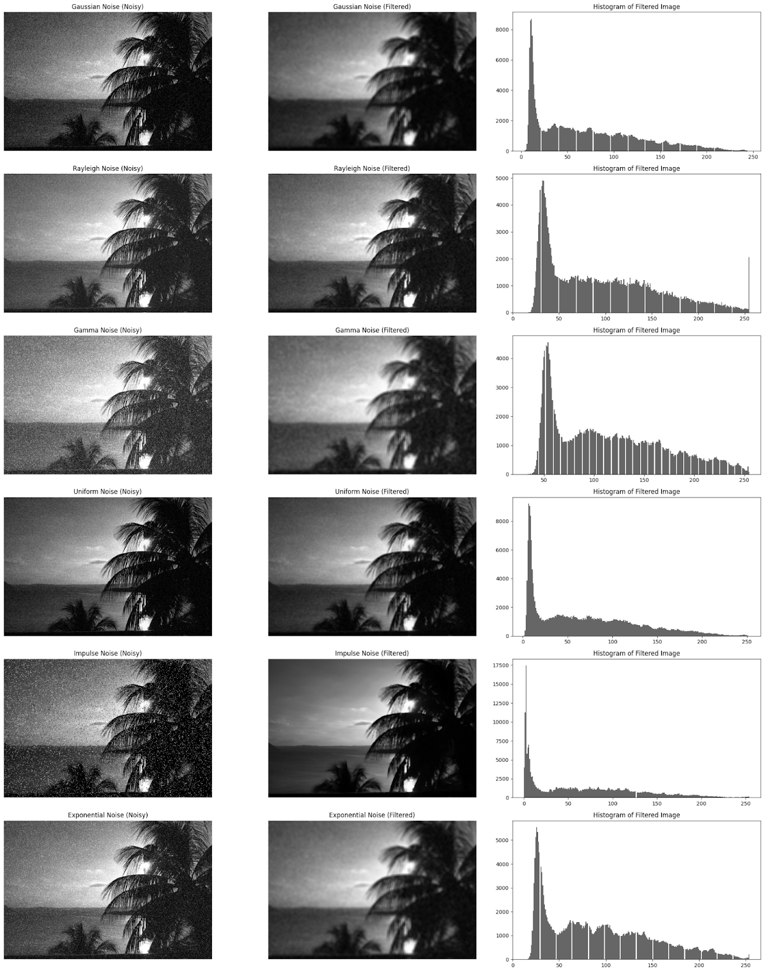

**INFERENCE:**

* Mean Filter: Blurs the image significantly.
* Gaussian Filter: Smooths noise while preserving edges better than Mean Filter.
* Median Filter: Very effective for Salt & Pepper noise.
* Bilateral Filter: Best at edge preservation while reducing noise.

**SOBEL EDGE DETECTION (3×3 AND 5×5):**

**ALGORITHM:**

1. Define Sobel kernels (3×3 and 5×5).
2. Apply convolution to compute gradient in x and y directions.
3. Compute gradient magnitude: Gradient Magnitude=sqrt(Gx2+Gy2)
4. Normalize and display results.

**CODE SNIPPET:**

sobel_x_3x3 = np.array([[-1, 0, 1],

[-2, 0, 2],

[-1, 0, 1]])

sobel_y_3x3 = np.array([[1, 2, 1],

[ 0, 0, 0],

[ -1, -2, -1]])

sobel_x_5x5 = np.array([[-1, -2, 0, 2, 1],

[-2, -3, 0, 3, 2],

[-3, -5, 0, 5, 3],

[-2, -3, 0, 3, 2],

[-1, -2, 0, 2, 1]])

sobel_y_5x5 = np.array([[1, 2, 3, 2, 1],

[2, 3, 5, 3, 2],

[ 0, 0, 0, 0, 0],

[ -2, -3, -5, 3, 2],

[-1, -2, -3, -2, -1]])

def apply_convolution(image, kernel):

pad = kernel.shape[0] // 2

padded_image = np.pad(image, pad, mode='edge')

result = np.zeros_like(image, dtype=np.float64)

for i in range(image.shape[0]):

for j in range(image.shape[1]):

region = padded_image[i:i+kernel.shape[0], j:j+kernel.shape[1]]

result[i, j] = np.sum(region * kernel)

return result

grad_x_3x3 = apply_convolution(image, sobel_x_3x3)

grad_y_3x3 = apply_convolution(image, sobel_y_3x3)

sobel_mag_3x3 = np.sqrt(grad_x_3x3**2 + grad_y_3x3**2)

grad_x_5x5 = apply_convolution(image, sobel_x_5x5)

grad_y_5x5 = apply_convolution(image, sobel_y_5x5)

sobel_mag_5x5 = np.sqrt(grad_x_5x5**2 + grad_y_5x5**2)

sobel_mag_3x3 = np.clip(sobel_mag_3x3, 0, 255).astype(np.uint8)

sobel_mag_5x5 = np.clip(sobel_mag_5x5, 0, 255).astype(np.uint8)

titles = ["Original", "Sobel 3x3", "Sobel 5x5"]

images = [image, sobel_mag_3x3, sobel_mag_5x5]

fig, axes = plt.subplots(3, 2, figsize=(12, 9))

for i in range(3):

axes[i, 0].imshow(images[i], cmap="gray")

axes[i, 0].set_title(titles[i])

axes[i, 0].axis("off")

axes[i, 1].hist(images[i].ravel(), bins=256, color='black', alpha=0.7)

axes[i, 1].set_title(f"Histogram of {titles[i]} Image")

plt.tight_layout()

plt.show()

**OUTPUT:**

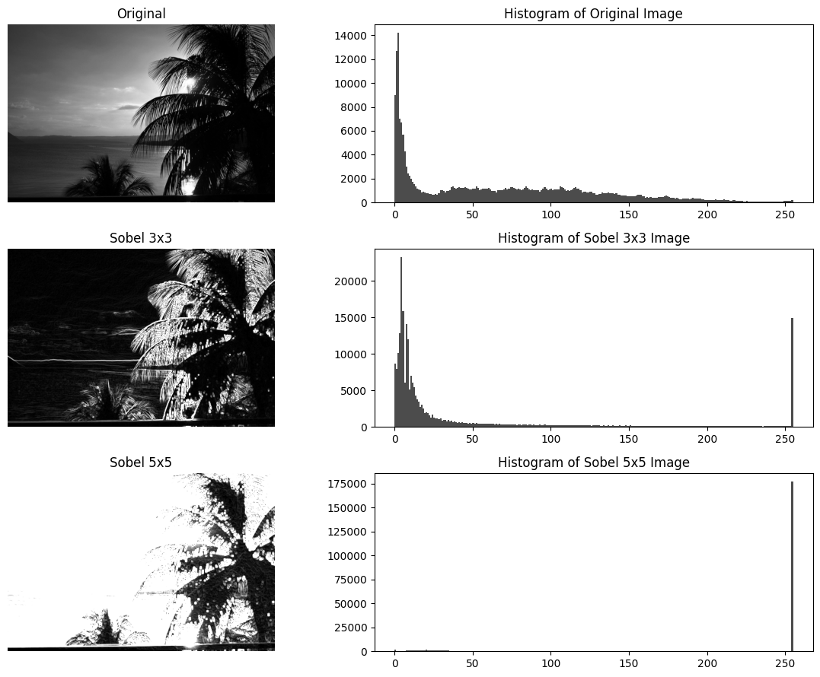

**INFERENCE:**

* **Sobel 3×3**: Detects sharper edges.
* **Sobel 5×5**: More sensitive to noise but captures finer details.

**RESULT:**

The experiments demonstrate how noise impacts image clarity, how different filters effectively reduce noise, and how Sobel operators help in detecting edges with varying levels of detail.

|  |  |
| --- | --- |
| **EX.NO:6**  **DATE:20/02/25** | **EDGE DETECTION AND FILTER APPLICATION** |

**AIM:**

To implement and compare various edge detection techniques for identifying object boundaries in images.

**FUNCTIONS USED:**

* **cv2.imread()** – Loads an image from a specified path.
* **cv2.cvtColor()** – Converts images between color spaces (e.g., BGR to RGB or grayscale).
* **cv2.GaussianBlur()** – Applies Gaussian blur to smooth the image and reduce noise
* **cv2.Sobel()** – Computes image gradients in the x and y directions.
* **cv2.Laplacian()** – Computes the Laplacian of the image for second-order edge detection.
* **cv2.filter2D()** – Applies custom convolution filters (e.g., Roberts and Prewitt kernels).
* **np.sqrt()** – Computes the magnitude of the gradient.
* **cv2.magnitude()** – Calculates the Euclidean magnitude of the gradient vectors.
* **cv2.phase()** – Computes the direction (angle) of the gradient.
* **np.round()** – Rounds values to the nearest integer (for non-maximum suppression).
* **np.zeros_like()** – Creates a zero matrix for edge output storage.
* **np.any()** – Checks if weak edges are connected to strong edges (hysteresis).

**cv2.normalize()** – Normalizes pixel intensities to a specific range (e.g., 0 to 255).

**CODE SNIPPET:**

import cv2

import numpy as np

import matplotlib.pyplot as plt

image=cv2.imread("img1.jpg")

image=cv2.cvtColor(image,cv2.COLOR_BGR2RGB)

plt.imshow(image)

plt.axis('off')

plt.show()

**OUTPUT:**

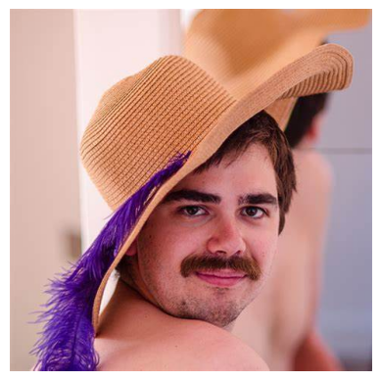

**1) CANNY EDGE DETECTION**

**ALGORITHM:**

1. **Input**: Grayscale image, low and high thresholds, Gaussian blur parameters.
2. **Apply Gaussian Blur**: Smooth the image using a Gaussian filter to reduce noise.
3. **Compute Gradients**: Use the Sobel operator to calculate gradients in the x and y directions.
4. **Find Gradient Magnitude and Direction**: Measure the edge strength and determine the direction of intensity change.
5. **Non-Maximum Suppression**: Suppress non-edge pixels by keeping only local maxima in the gradient direction.
6. **Double Thresholding**: Classify pixels as strong edges (above the high threshold) and weak edges (between low and high thresholds).
7. **Edge Tracking by Hysteresis**: Retain weak edges if they are connected to strong edges.
8. **Output**: Binary image highlighting the edges.

**CODE SNIPPET:**

def gaussian_blur(image, kernel_size=5, sigma=1.0):

    return cv2.GaussianBlur(image, (kernel_size, kernel_size), sigma)

def sobel_gradient(image):

    grad_x = cv2.Sobel(image, cv2.CV_64F, 1, 0, ksize=3)

    grad_y = cv2.Sobel(image, cv2.CV_64F, 0, 1, ksize=3)

    grad_mag = cv2.magnitude(grad_x, grad_y)

    grad_dir = cv2.phase(grad_x, grad_y, angleInDegrees=True)

    return grad_mag, grad_dir

def non_maximum_suppression(grad_mag, grad_dir):

    rows, cols = grad_mag.shape

    output = np.zeros_like(grad_mag)

    grad_dir = np.round(grad_dir) % 180

    for i in range(1, rows-1):

        for j in range(1, cols-1):

            angle = grad_dir[i, j]

            if (0 <= angle < 45) or (135 <= angle < 180):

                p1, p2 = grad_mag[i, j+1], grad_mag[i, j-1]

            elif (45 <= angle < 90) or (90 <= angle < 135):

                p1, p2 = grad_mag[i+1, j-1], grad_mag[i-1, j+1]

            if grad_mag[i, j] >= p1 and grad_mag[i, j] >= p2:

                output[i, j] = grad_mag[i, j]

            else:

                output[i, j] = 0

    return output

def double_thresholding(grad_mag, low_threshold, high_threshold):

    strong_edges = np.zeros_like(grad_mag)

    weak_edges = np.zeros_like(grad_mag)

    strong_edges[grad_mag >= high_threshold] = 1

    weak_edges[(grad_mag >= low_threshold) & (grad_mag < high_threshold)] = 1

    return strong_edges, weak_edges

def hysteresis(strong_edges, weak_edges):

    rows, cols = strong_edges.shape

    final_edges = np.copy(strong_edges)

    for i in range(1, rows-1):

        for j in range(1, cols-1):

            if weak_edges[i, j] == 1:

                if np.any(strong_edges[i-1:i+2, j-1:j+2]):

                    final_edges[i, j] = 1

    return final_edges

def canny_edge_detection(image, low_threshold=50, high_threshold=150, kernel_size=5, sigma=1.0):

    image = np.float32(image)

    blurred_image = gaussian_blur(image, kernel_size, sigma)

    grad_mag, grad_dir = sobel_gradient(blurred_image)

    nms_edges = non_maximum_suppression(grad_mag, grad_dir)

    strong_edges, weak_edges = double_thresholding(nms_edges, low_threshold, high_threshold)

    final_edges = hysteresis(strong_edges, weak_edges)

    steps = [

        ("Original Image", image),

        ("Gaussian Blurred Image", blurred_image),

        ("Gradient Magnitude", grad_mag),

        ("Non-Maximum Suppression", nms_edges),

        ("Strong Edges", strong_edges),

        ("Final Edges", final_edges)

    ]

    plt.figure(figsize=(15, 10))

    for i, (title, img) in enumerate(steps, 1):

        plt.subplot(3, 3, i)

        plt.imshow(img, cmap='gray')

        plt.title(title)

        plt.axis('off')

        plt.show()

image_path = 'img1.jpg'

image = cv2.imread(image_path, cv2.IMREAD_GRAYSCALE)

canny_edge_detection(image)

**OUTPUT:**

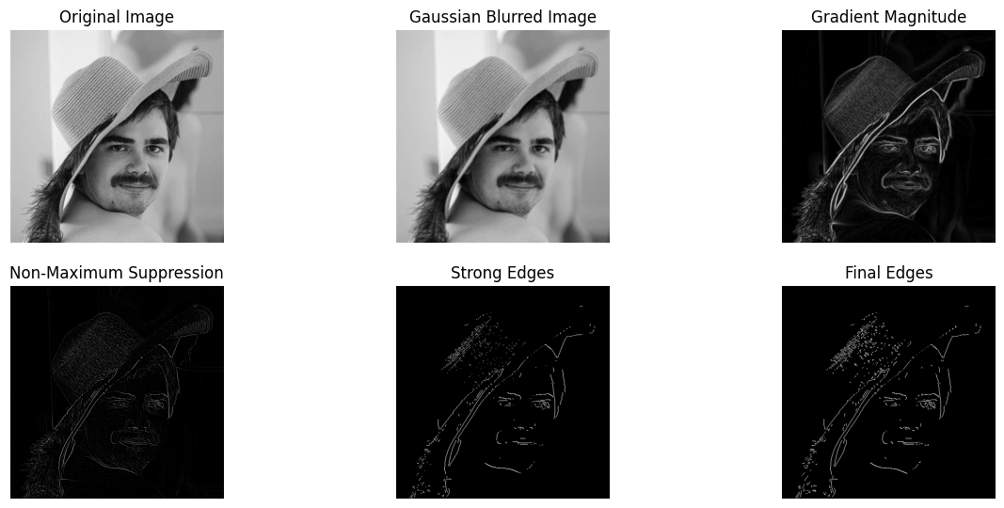

**INFERENCE:**

* Gaussian blur smoothens the image, reducing noise.
* Sobel operator computes gradients in the x and y directions to find edge strength and direction.
* Non-maximum suppression removes weak gradients that are not part of edges.
* Double thresholding classifies pixels into strong, weak, and non-edges.
* Hysteresis eliminates weak edges unless they are connected to strong edges.

**2) LoG**

**ALGORITHM:**

1) **Input**: Grayscale image, Gaussian blur parameters.

2) **Apply Gaussian Blur**: Smooth the image to reduce noise.

3) **Compute the Laplacian**: Apply the Laplacian operator to detect areas with rapid intensity changes.

4) **Detect Zero Crossings**: Identify edge pixels where the Laplacian value changes sign.

5) **Output**: Edge-detected image with fine details.

**CODE SNIPPET:**

def apply_gaussian_blur(image, sigma, kernel_size=(5,5)):

     return cv2.GaussianBlur(image,kernel_size, sigma)

def laplacian_filter(image):

    return cv2.Laplacian(image, cv2.CV_64F)

def laplacian_of_gaussian(image, sigma):

    blurred_image = apply_gaussian_blur(image, sigma)

    log_image = laplacian_filter(blurred_image)

    return log_image

sigma = 1.4

log_result = laplacian_of_gaussian(image, sigma)

plt.imshow(log_result, cmap='gray')

plt.title("Laplacian of Gaussian")

plt.axis('off')

plt.show()

**OUTPUT:**

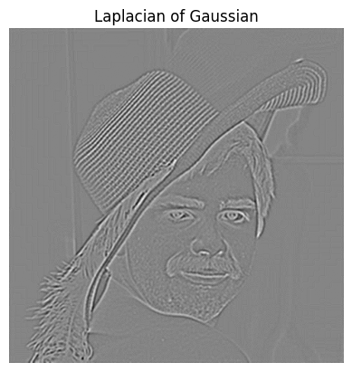

**INFERENCES:**

* Gaussian blur reduces noise before applying the Laplacian filter.
* The Laplacian filter detects regions with rapid intensity changes.
* This method is more sensitive to fine details compared to the Canny method.

**3) DoG**

**ALGORITHM:**

1) **Input**: Grayscale image, two different Gaussian blur parameters (sigma values).

2) **Apply Gaussian Blur**: Smooth the image using two Gaussian filters with different standard deviations.

3) **Subtract Blurred Images**: Compute the difference between the two blurred images to enhance edges.

4) **Detect Edges**: Identify significant intensity changes as edges.

5) **Output**: Edge-detected image with improved focus on object boundaries.

**CODE SNIPPET:**

def apply_gaussian_blur(image, sigma, kernel_size=(5,5)):

     return cv2.GaussianBlur(image,kernel_size, sigma)

def difference_of_gaussians(image, sigma1, sigma2):

    blurred_image_1 = apply_gaussian_blur(image, sigma1)

    blurred_image_2 = apply_gaussian_blur(image, sigma2)

    dog_image = blurred_image_1 - blurred_image_2

    return dog_image

def dog(image, sigma1, sigma2):

    dog_result = difference_of_gaussians(image, sigma1, sigma2)

    return dog_result

sigma1 = 1.0

sigma2 = 2.0

dog_result = dog(image, sigma1, sigma2)

plt.imshow(dog_result, cmap='gray')

plt.title("Difference of Gaussian")

plt.axis('off')

plt.show()

**OUTPUT:**

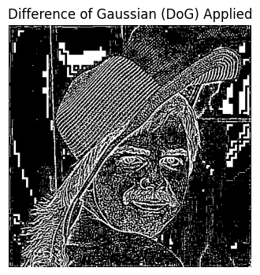

**INFERENCES:**

* Applying two different levels of Gaussian blur helps enhance edge details.
* The subtraction operation removes low-frequency components, highlighting edges.
* It is computationally efficient compared to LoG and is used in blob detection.

**4) ROBERT AND PREWITT FILTER:**

**ALGORITHM:**

**Roberts Edge Detection Algorithm**

1. **Input**: Grayscale image.
2. **Apply Roberts Cross Operator**: Use two 2×2 kernels to compute gradients along diagonal directions.
3. **Compute Gradient Magnitude**: Measure the intensity of edges by combining the gradients.
4. **Normalize Image**: Scale the result for better visualization.
5. **Output**: Edge-detected image, highlighting sharp transitions.

**Prewitt Edge Detection Algorithm**

1. **Input**: Grayscale image.
2. **Apply Prewitt Operator**: Use two 3×3 kernels to calculate gradients in the horizontal and vertical directions.
3. **Compute Gradient Magnitude**: Combine the gradient components to detect edges.
4. **Normalize Image**: Adjust the pixel intensities for clearer visualization.
5. **Output**: Edge-detected image with better noise resistance.

**CODE SNIPPET:**

def roberts_filter(image):

    kernel_x = np.array([[1, 0], [0, -1]], dtype=np.float32)

    kernel_y = np.array([[0, 1], [-1, 0]], dtype=np.float32)

    grad_x = cv2.filter2D(image, cv2.CV_64F, kernel_x)

    grad_y = cv2.filter2D(image, cv2.CV_64F, kernel_y)

    roberts_edge = np.sqrt(grad_x**2 + grad_y**2)

    roberts_edge = cv2.normalize(roberts_edge, None, 0, 255, cv2.NORM_MINMAX)

    return np.uint8(roberts_edge)

def prewitt_filter(image):

    kernel_x = np.array([[1, 0, -1], [1, 0, -1], [1, 0, -1]], dtype=np.float32)

    kernel_y = np.array([[1, 1, 1], [0, 0, 0], [-1, -1, -1]], dtype=np.float32)

    grad_x = cv2.filter2D(image, cv2.CV_64F, kernel_x)

    grad_y = cv2.filter2D(image, cv2.CV_64F, kernel_y)

    prewitt_edge = np.sqrt(grad_x**2 + grad_y**2)

    prewitt_edge = cv2.normalize(prewitt_edge, None, 0, 255, cv2.NORM_MINMAX)

    return np.uint8(prewitt_edge)

image_path = 'img1.jpeg'

image = cv2.imread(image_path, cv2.IMREAD_GRAYSCALE)

filters = {

    "Original Image": image,

    "Roberts Edge Detection": roberts_filter(image),

    "Prewitt Edge Detection": prewitt_filter(image)

}

plt.figure(figsize=(12, 6))

for i, (title, result) in enumerate(filters.items(), 1):

    plt.subplot(1, 3, i)

    plt.imshow(result, cmap='gray')

    plt.title(title)

    plt.axis('off')

plt.show()

**OUTPUT:**

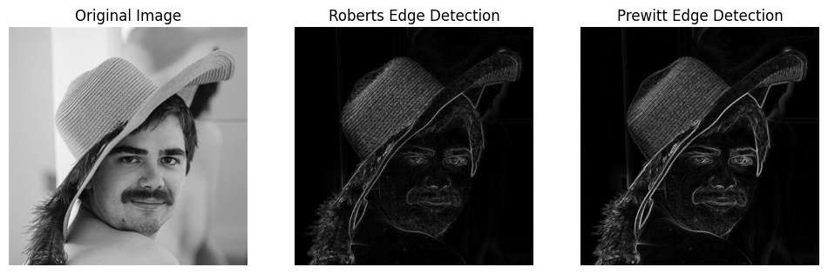

**INFERENCES:**

* **Roberts filter** uses a 2x2 kernel and is sensitive to noise but detects sharp edges.
* **Prewitt filter** uses a 3x3 kernel, providing better noise resistance but lower accuracy for diagonal edges.

**RESULT:**

The Canny method provides the most precise edges with noise reduction, while LoG and DoG enhance fine details. Roberts and Prewitt are simpler but more sensitive to noise, making them less accurate for complex images.

|  |  |
| --- | --- |
| EX.NO:7  DATE:27/2/25 | **REGION GROWING** |

**AIM:**

Implement the region-growing algorithm to segment an image by identifying and extracting regions with pixel intensities similar to a given seed point.

**FUNCTIONS USED:**

1. np.zeros_like() – Initialize matrices.
2. deque() – Efficient queue implementation.

**ALGORITHM:**

1. **Input:** Grayscale image, seed point, similarity threshold.
2. **Initialize:**
   * Create region and visited matrices (zeros).
   * Add seed point to the queue and mark it as visited.
3. **Process:**
   * While the queue is not empty:
     + Dequeue the current pixel.
     + Check its 4 neighbors.
     + If the neighbor is unvisited and intensity difference < threshold:
       - Add to the region and queue.
       - Mark as visited.
4. **Output:** Return the segmented region.

**CODE SNIPPET:**

from collections import deque

image_path = 'img4.jpg'

image = cv2.imread(image_path)

image_gray = cv2.cvtColor(image, cv2.COLOR_BGR2GRAY)

threshold = 1

region = np.zeros_like(image_gray)

seed_x, seed_y = 50, 80

def region_growing_seed(image, seed_x, seed_y, threshold):

    region = np.zeros_like(image)

    visited = np.zeros_like(image)

    queue = deque([(seed_x, seed_y)])

    region[seed_x, seed_y] = 1

    visited[seed_x, seed_y] = 1

    while queue:

        current_x, current_y = queue.popleft()

  for dx, dy in [(-1, 0), (1, 0), (0, -1), (0, 1)]:

            nx, ny = current_x + dx, current_y + dy

            if 0 <= nx < image.shape[0] and 0 <= ny < image.shape[1]:

                if visited[nx, ny] == 0 and abs(int(image[nx, ny]) - int(image[current_x, current_y])) < threshold:

                    region[nx, ny] = 1

                    visited[nx, ny] = 1

                    queue.append((nx, ny))

  return region

region = region_growing_seed(image_gray, seed_x, seed_y, threshold)

plt.figure(figsize=(12, 6))

plt.subplot(1, 2, 1)

plt.imshow(image_gray, cmap='gray')

plt.title('Original Image')

plt.subplot(1, 2, 2)

plt.imshow(region, cmap='gray')

plt.title('Region Growing from Seed')

plt.show()

**OUTPUT:**

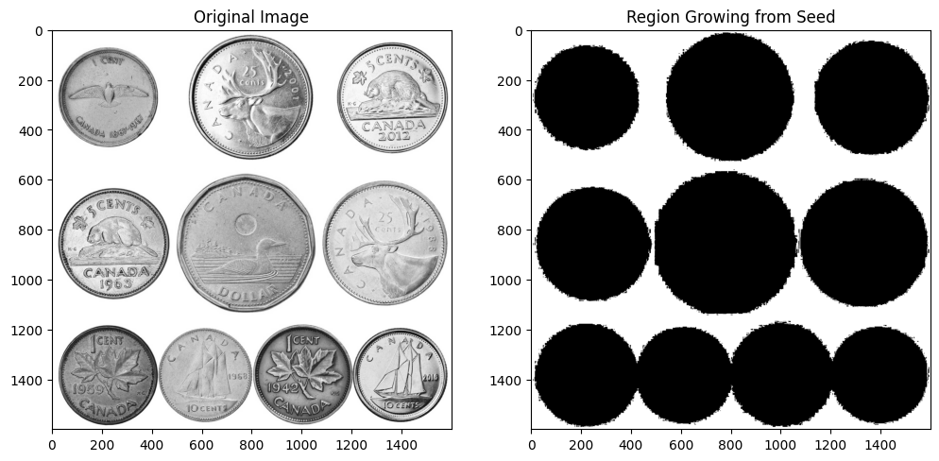

**INFERENCES:**

**Threshold Effect:** Small values segment fine regions; large values segment broader areas.

**Seed Dependency:** Different seed points yield different regions.

**Connectivity:** Uses 4-connectivity (left, right, top, bottom).

**RESULT:**

The algorithm segments the image by identifying regions with pixel intensities similar to the seed point. The output shows the original image and the corresponding segmented region.

|  |  |
| --- | --- |
| **EX.NO: 8**  **DATE:06/03/25** | **HOUGH AND HARRIS TRANSFORM** |

**AIM:**

To perform hough and harris transform and also perform image segmentation using this.

**FUNCTIONS USED:**

1. cv2.Canny(): Detects edges in an image.
2. cv2.HoughLinesP(): Detects straight lines using the Probabilistic Hough Transform.
3. cv2.cornerHarris(): Identifies corner points using the Harris Corner Detection method.
4. cv2.dilate(): Enhances detected features by expanding bright regions.
5. cv2.line(): Draws lines on an image.
6. cv2.circle(): Marks specific points on an image.
7. cv2.addWeighted(): Blends two images with adjustable transparency.
8. **LINE DETECTION USING HOUGH TRANSFORM**

**ALGORITHM:**

1. Load and convert the image to RGB.
2. Convert to grayscale and apply Canny edge detection.
3. Use cv2.HoughLinesP() to detect lines.
4. Draw detected lines on the image.

5.Display the processed image.

**CODE SNIPPET:**

mport cv2

import numpy as np

import matplotlib.pyplot as plt

image = cv2.imread("C:/Users/student/Pictures/Saved Pictures/logo.jpg")

image = cv2.cvtColor(image, cv2.COLOR_BGR2RGB)

plt.imshow(image)

plt.axis('off')

plt.show()

**OUTPUT:**



**CODE SNIPPET:**

  gray = cv2.cvtColor(image, cv2.COLOR_BGR2GRAY)

edges = cv2.Canny(gray, 50, 200)

plt.imshow(edges,cmap='grey')

**OUTPUT:**

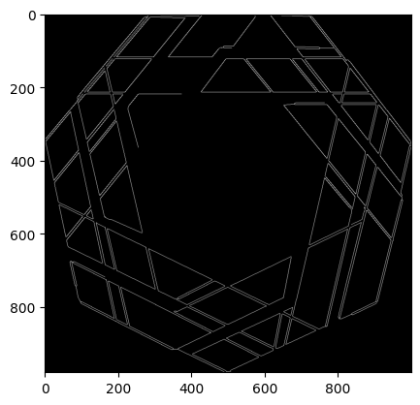

**CODE SNIPPET:**

lines = cv2.HoughLinesP(edges, 1, np.pi/180, 68, minLineLength=50, maxLineGap=5)

for line in lines:

   x1, y1, x2, y2 = line[0]

   cv2.line(image, (x1, y1), (x2, y2), (255, 0, 0), 3)

print("Line Detection using Hough Transform")

plt.imshow(image)

**OUTPUT:**

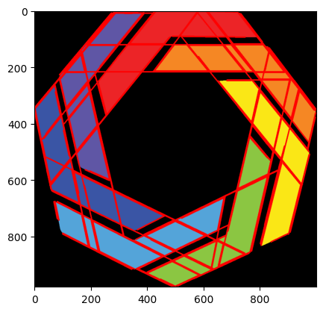

**INFERENCES:**

Effectively detects straight-line structures. minLineLength and maxLineGap influence detection accuracy. Higher thresholds reduce noise but may miss faint edges.

**2. HARRIS CORNER DETECTION**

**ALGORITHM:**

1. Load and convert the image to grayscale.
2. Apply cv2.cornerHarris() for corner detection.
3. Dilate the result and apply a threshold.
4. Highlight detected corners in red.
5. Display the original and processed images.

**CODE SNIPPET:**

image_path = r"C:\Users\yuval\OneDrive\Pictures\box.jpg"

image = cv2.imread(image_path)

image_rgb = cv2.cvtColor(image, cv2.COLOR_BGR2RGB)

gray = cv2.cvtColor(image_rgb, cv2.COLOR_RGB2GRAY)

harris_corners = cv2.cornerHarris(gray, blockSize=3, ksize=3, k=0.04)

harris_corners = cv2.dilate(harris_corners, None)

image_with_corners = image_rgb.copy()

image_with_corners[harris_corners > 0.01 * harris_corners.max()] = [255, 0, 0]

fig, axes = plt.subplots(1, 2, figsize=(12, 6))

axes[0].imshow(image_rgb)

axes[0].set_title("Original Image")

axes[0].axis('off')

axes[1].imshow(image_with_corners)

axes[1].set_title("Harris Corner Detection")

axes[1].axis('off')

plt.show()

**OUTPUT:**

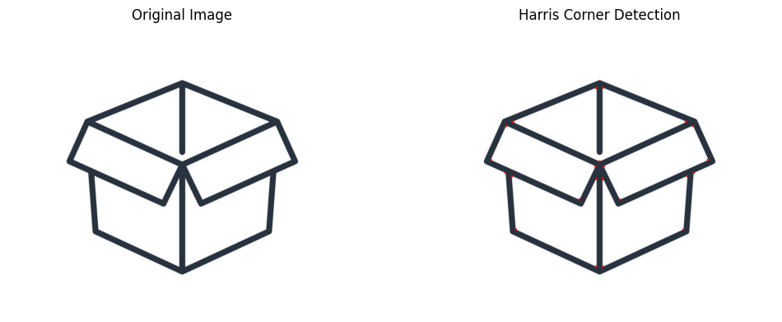

**INFERENCES:**

* Harris detector identifies strong corner points.
* Sensitive to noise; dilation improves visualization.
* Lower k detects more corners; higher k refines selection.

**3. COMBINED LINE & CORNER DETECTION**

**ALGORITHM:**

1. Apply Harris corner detection.
2. Use Canny edge detection and Hough Transform to detect lines.
3. Overlay detected lines and corners on the original image.
4. Display segmented results.

**CODE SNIPPET:**

image_path = r"C:\Users\yuval\OneDrive\Pictures\box.jpg"

image = cv2.imread(image_path)

gray = cv2.cvtColor(image, cv2.COLOR_BGR2GRAY)

gray_float = np.float32(gray)

dst = cv2.cornerHarris(gray_float, blockSize=2, ksize=3, k=0.04)

dst = cv2.dilate(dst, None)

corner_image = image.copy()

threshold = 0.01 * dst.max()

for y, x in np.argwhere(dst > threshold):

    cv2.circle(corner_image, (x, y), 5, (0, 0, 255), -1)

edges = cv2.Canny(gray, 50, 150, apertureSize=3)

lines = cv2.HoughLinesP(edges, 1, np.pi / 180, threshold=80,

minLineLength=30, maxLineGap=5)

line_image = np.zeros_like(image)

if lines is not None:

    for line in lines:

        x1, y1, x2, y2 = line[0]

        cv2.line(line_image, (x1, y1), (x2, y2), (0, 255, 0), 2)

segmented_image = image.copy()

segmented_image = cv2.addWeighted(segmented_image, 0.8, line_image, 1,

0)

for y, x in np.argwhere(dst > threshold):

    cv2.circle(segmented_image, (x, y), 5, (0, 0, 255), -1)

fig, axes = plt.subplots(2, 2, figsize=(10, 7))

axes[0, 0].imshow(cv2.cvtColor(image, cv2.COLOR_BGR2RGB))

axes[0, 0].set_title("Original Image")

axes[0, 0].axis("off")

axes[0, 1].imshow(cv2.cvtColor(corner_image, cv2.COLOR_BGR2RGB))

axes[0, 1].set_title("Harris Corner Detection (Larger)")

axes[0, 1].axis("off")

axes[1, 0].imshow(cv2.cvtColor(line_image, cv2.COLOR_BGR2RGB))

axes[1, 0].set_title("Hough Line Detection")

axes[1, 0].axis("off")

axes[1, 1].imshow(cv2.cvtColor(segmented_image, cv2.COLOR_BGR2RGB))

axes[1, 1].set_title("Segmented Image (Lines & Corners)")

axes[1, 1].axis("off")

plt.tight_layout()

plt.show()

**OUTPUT:**

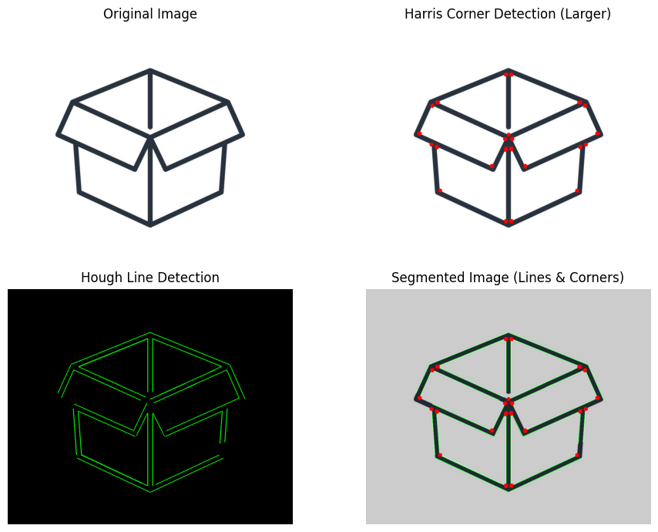

**INFERENCES:**

1. Enhances feature extraction for structured objects.
2. Harris detects junctions, Hough identifies edges.
3. Parameter tuning optimizes detection accuracy.

**RESULT:**

Thus, hough transform and harris transform were performed successfully

|  |  |
| --- | --- |
| **EX.NO:9**  **DATE:13/3/25** | **IMAGE CLASSIFICATION AND OBJECT DETECTION** |

**AIM:**

To perform image classification and object detection using SIFT, HOG, and GLOH features. It classifies images and detects objects using feature matching and Homography transformation.

**IMAGE CLASSIFICATION:**

import pickle

import os

import numpy as np

import cv2

from skimage.feature import hog

from sklearn.ensemble import RandomForestClassifier as rf

from sklearn.model_selection import train_test_split

from sklearn.preprocessing import StandardScaler

from sklearn.metrics import accuracy_score

import matplotlib.pyplot as plt

dataset_path = r"C:\Users\yuval\Downloads\cifar-10-python\cifar-10-batches-py"

batch_file = os.path.join(dataset_path, "data_batch_1")

meta_file = os.path.join(dataset_path, "batches.meta")

with open(meta_file, 'rb') as f:

class_names = pickle.load(f, encoding='bytes')[b'label_names']

class_names = [name.decode('utf-8') for name in class_names]

with open(batch_file, 'rb') as f:

batch = pickle.load(f, encoding='bytes')

images = batch[b'data']

labels = batch[b'labels']

images = images.reshape(-1, 3, 32, 32).transpose(0, 2, 3, 1)

cat_index = class_names.index("cat")

cat_images = [img for img, label in zip(images, labels) if label == cat_index]

cat_labels = [label for label in labels if label == cat_index]

cat_images = np.array(cat_images)

cat_labels = np.array(cat_labels)

plt.figure(figsize=(10, 5))

for i in range(5):

plt.subplot(1, 5, i + 1)

plt.imshow(cv2.cvtColor(cat_images[i], cv2.COLOR_RGB2BGR))

plt.axis('off')

plt.suptitle("Sample Cat Images from data_batch_1")

plt.show()

print(f"Total Cat Images Extracted: {len(cat_images)}")

X, y = [], []

for i, img in enumerate(cat_images):

gray_img = cv2.cvtColor(img, cv2.COLOR_RGB2GRAY) # Convert to grayscale

gray_img = cv2.resize(gray_img, (128, 128)) # Resize for feature extraction

sift = cv2.SIFT_create()

keypoints, descriptors = sift.detectAndCompute(gray_img, None)

sift_feat = np.mean(descriptors, axis=0) if descriptors is not None else np.zeros((128,))

hog_feat, _ = hog(gray_img, pixels_per_cell=(8, 8), cells_per_block=(2, 2),

orientations=9, visualize=True)

gloh_feat = np.var(descriptors, axis=0) if descriptors is not None else np.zeros((128,))

features = np.hstack((sift_feat, hog_feat, gloh_feat))

X.append(features)

y.append(cat_labels[i])

X = np.array(X)

y = np.array(y)

scaler = StandardScaler()

X = scaler.fit_transform(X)

X_train, X_test, y_train, y_test = train_test_split(X, y, test_size=0.2, random_state=42)

clf = rf(n_estimators=100, random_state=42)

clf.fit(X_train, y_train)

y_pred = clf.predict(X_test)

accuracy = accuracy_score(y_test, y_pred)

print(f"Model Training Complete. Accuracy: {accuracy:.4f}")

def classify_image(image_path):

image = cv2.imread(image_path)

image = cv2.cvtColor(image, cv2.COLOR_RGB2GRAY)

image = cv2.resize(image, (128, 128))

sift = cv2.SIFT_create()

keypoints, descriptors = sift.detectAndCompute(image, None)

sift_feat = np.mean(descriptors, axis=0) if descriptors is not None else np.zeros((128,))

hog_feat, _ = hog(image, pixels_per_cell=(8, 8), cells_per_block=(2, 2),

orientations=9, visualize=True)

gloh_feat = np.var(descriptors, axis=0) if descriptors is not None else np.zeros((128,))

features = np.hstack((sift_feat, hog_feat, gloh_feat)).reshape(1, -1)

features = scaler.transform(features)

pred_label = clf.predict(features)[0]

predicted_class = class_names[pred_label]

print(f"Predicted Class: {predicted_class}")

test_image_path = r"C:\Users\yuval\OneDrive\Pictures\cat.jpg"

classify_image(test_image_path)

**OUTPUT:**

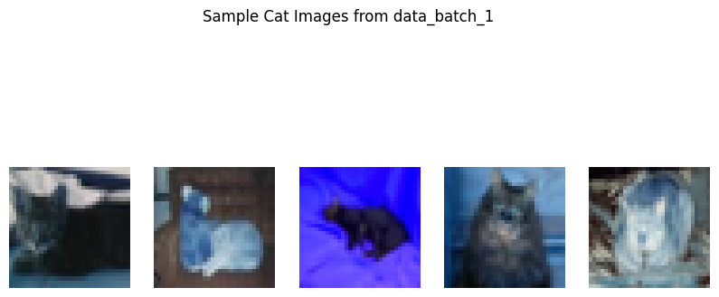

Total Cat Images Extracted: 1016

Model Training Complete. Accuracy: 1.0000

Predicted Class: cat

**OBJECT DETECTION:**

import cv2

import numpy as np

import matplotlib.pyplot as plt

object_img = cv2.imread(r"C:\Users\yuval\Downloads\python.jpg", cv2.IMREAD_GRAYSCALE)

scene_img = cv2.imread(r"C:\Users\yuval\Downloads\grp_prog.jpg", cv2.IMREAD_GRAYSCALE)

sift = cv2.SIFT_create()

keypoints_obj, descriptors_obj = sift.detectAndCompute(object_img, None)

keypoints_scene, descriptors_scene = sift.detectAndCompute(scene_img, None)

flann_index_kdtree = 1

index_params = dict(algorithm=flann_index_kdtree, trees=5)

search_params = dict(checks=50)

flann = cv2.FlannBasedMatcher(index_params, search_params)

matches = flann.knnMatch(descriptors_obj, descriptors_scene, k=2)

good_matches = [m for m, n in matches if m.distance < 0.75 * n.distance]

scene_img_bgr = cv2.imread(r"C:\Users\Jaiprakash S\Downloads\grp_prog.jpg")

if len(good_matches) > 10:

# Get keypoints from the good matches

src_pts = np.float32([keypoints_obj[m.queryIdx].pt for m in good_matches]).reshape(-1, 1, 2)

dst_pts = np.float32([keypoints_scene[m.trainIdx].pt for m in good_matches]).reshape(-1, 1, 2)

matrix, mask = cv2.findHomography(src_pts, dst_pts, cv2.RANSAC, 5.0)

h, w = object_img.shape

obj_corners = np.float32([[0, 0], [w, 0], [w, h], [0, h]]).reshape(-1, 1, 2)

scene_corners = cv2.perspectiveTransform(obj_corners, matrix)

cv2.polylines(scene_img_bgr, [np.int32(scene_corners)], True, (0, 255, 0), 3, cv2.LINE_AA)

mask = np.zeros(scene_img_bgr.shape[:2], dtype=np.uint8)

scene_corners = np.int32(scene_corners) # Ensure integer points

cv2.fillPoly(mask, [scene_corners], 255)

segmented_object = cv2.bitwise_and(scene_img_bgr, scene_img_bgr, mask=mask)

cv2.imwrite("detected_object.png", scene_img_bgr)

cv2.imwrite("segmented_object.png", segmented_object)

plt.figure(figsize=(10, 5))

plt.subplot(1, 3, 1)

plt.imshow(object_img, cmap="gray")

plt.title("Object to Detect")

plt.axis("off")

plt.subplot(1, 3, 2)

plt.imshow(cv2.cvtColor(scene_img_bgr, cv2.COLOR_BGR2RGB))

plt.title("Detected Object with Bounding Box")

plt.axis("off")

plt.subplot(1, 3, 3)

plt.imshow(cv2.cvtColor(segmented_object, cv2.COLOR_BGR2RGB))

plt.title("Segmented Object")

plt.axis("off")

plt.show()

else:

print("Object not detected.")

**OUTPUT:**

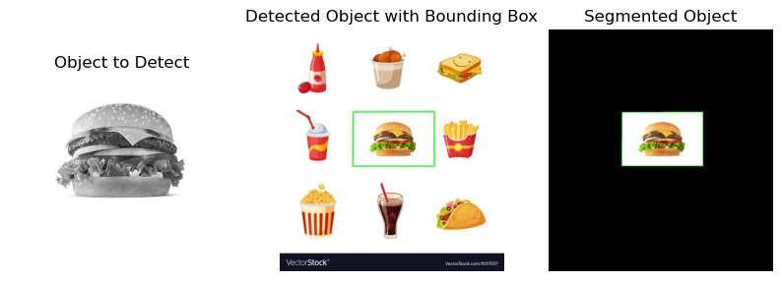

**RESULT:**

The code classifies images using feature extraction and detects objects using SIFT and Homography for accurate recognition.

|  |  |
| --- | --- |
| **EX.NO:10**  **DATE:20/03/25** | **SEGMENTATION** |

**AIM:**

To segment an image into meaningful regions by distinguishing objects from the background using different techniques.

**THRESHOLDING:**

**ALGORITHM:**

1. Convert the given image into a grayscale image.
2. Create a binary image of the same shape as the grayscale image.
3. Compare each pixel value in the grayscale image with a predefined threshold value.
4. If the pixel value is greater than or equal to the threshold, set it to 255 (white).
5. If the pixel value is less than the threshold, set it to 0 (black).
6. Return the binary thresholded image.

**CODE SNIPPET:**

def thresholding(img, threshold_value=128):

    gray_image = cv2.cvtColor(img, cv2.COLOR_BGR2GRAY)

    binary_image = np.zeros_like(gray_image)

    binary_image[gray_image >= threshold_value] = 255

    binary_image[gray_image < threshold_value] = 0

    return binary_image

threshold_value = 128

segmented_image = thresholding(image, threshold_value)

plt.figure(figsize=(10, 5))

plt.subplot(1, 2, 1)

plt.title("Original Image")

plt.imshow(image)

plt.axis('off')

plt.subplot(1, 2, 2)

plt.title("Thresholded Image")

plt.imshow(segmented_image, cmap='gray')

plt.axis('off')

plt.show()

**OUTPUT:**

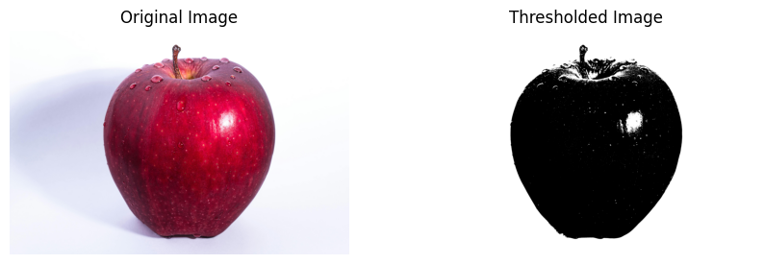

**GRAPH CUT:**

**ALGORITHM:**

1. Initialize a mask of the same size as the image and set all pixel values to zero.
2. Define a rectangular region containing the foreground object.
3. Initialize background and foreground models.
4. Apply the GrabCut algorithm:
5. Iterate through the image and classify pixels as foreground or background using energy minimization.
6. Update the background and foreground models accordingly.
7. Convert the final mask into a binary form where foreground pixels are assigned 1 and background pixels are assigned 0.
8. Multiply the original image with the binary mask to extract the segmented foreground.

**CODE SNIPPET:**

mask = np.zeros(image.shape[:2], np.uint8)

bg_model = np.zeros((1, 65), np.float64)

fg_model = np.zeros((1, 65), np.float64)

rect = (50, 50, image.shape[1] - 100, image.shape[0] - 100)

cv2.grabCut(image, mask, rect, bg_model, fg_model, 5, cv2.GC_INIT_WITH_RECT)

mask_final = np.where((mask == 2) | (mask == 0), 0, 1).astype("uint8")

segmented_image = image * mask_final[:, :, np.newaxis]

plt.figure(figsize=(10, 5))

plt.subplot(1, 2, 1)

plt.imshow(image)

plt.title("Original Image")

plt.axis("off")

plt.subplot(1, 2, 2)

plt.imshow(segmented_image)

plt.title("Segmented Image (Graph Cut)")

plt.axis("off")

plt.show()

**OUTPUT:**

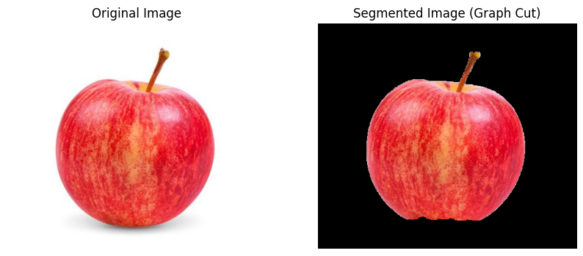

**MEAN SHIFT:**

**ALGORITHM:**

1. Define spatial and color radius parameters.
2. Apply the pyrMeanShiftFiltering function:
3. Shift pixel values iteratively based on spatial and color proximity.
4. Pixels with similar color intensities are clustered together.
5. Return the segmented image, where objects with similar color intensities are grouped together.

**CODE SNIPPET:**

spatial_radius = 100

color_radius = 30

segmented_image = cv2.pyrMeanShiftFiltering(image, spatial_radius, color_radius)

plt.figure(figsize=(10, 5))

plt.subplot(1, 2, 1)

plt.imshow(image)

plt.title("Original Image")

plt.axis("off")

plt.subplot(1, 2, 2)

plt.imshow(segmented_image)

plt.title("Segmented Image (Mean Shift)")

plt.axis("off")

plt.show()

**OUTPUT:**

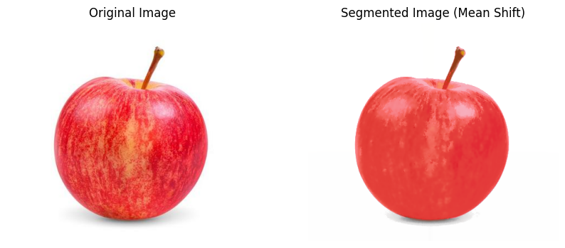

**K MEANS CLUSTERING:**

**ALGORITHM:**

1. Reshape the image into a 2D array where each pixel is treated as a data point.
2. Define the number of clusters KKK and the termination criteria.
3. Apply the K-Means clustering algorithm:

* Assign each pixel to the nearest cluster based on color similarity.
* Compute the new cluster centers by averaging the assigned pixels.
* Repeat the process until convergence or the maximum number of iterations is reached.

4.Replace pixel values with their corresponding cluster center values.

5.Reshape the clustered data back to the original image shape.

6.Return the segmented image.

**CODE SNIPPET:**

def k_means_segmentation(image, K=3, max_iter=10):

    pixels = image.reshape((-1, 3)).astype(np.float32)

    criteria = (cv2.TERM_CRITERIA_EPS + cv2.TERM_CRITERIA_MAX_ITER, max_iter, 1.0)

    _, labels, centers = cv2.kmeans(pixels, K, None, criteria, 10, cv2.KMEANS_RANDOM_CENTERS)

    centers = np.uint8(centers)

    segmented_pixels = centers[labels.flatten()]

    # Reshape back to the original image shape

    segmented_image = segmented_pixels.reshape(image.shape)

    return segmented_image

K = 3

segmented_image = k_means_segmentation(image, K=K, max_iter=10)

plt.figure(figsize=(10, 5))

plt.subplot(1, 2, 1)

plt.imshow(image)

plt.title("Original Image")

plt.axis("off")

plt.subplot(1, 2, 2)

plt.imshow(segmented_image)

plt.title(f"K-Means Segmentation (K={K})")

plt.axis("off")

plt.show()

**OUTPUT:**

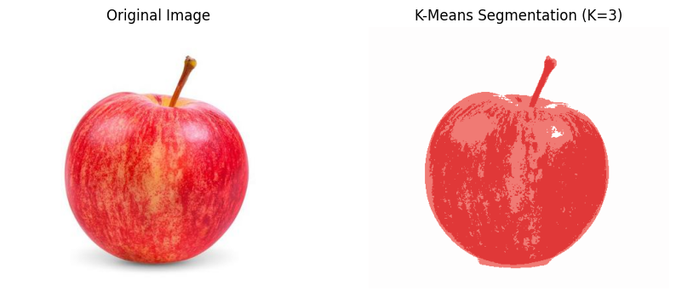

**REGION GROWING:**

**ALGORITHM:**

1. Initialize empty region and visited masks.
2. Set the seed pixel in the region mask and mark it as visited.
3. Use a queue to check neighboring pixels within the threshold.
4. If a neighbor meets the criteria, add it to the region and queue.
5. Repeat until all connected pixels are processed.

**CODE SNIPPET:**

from collections import deque

image_path = r"C:\Users\student\Pictures\Saved Pictures\apple.jpg"

image_gray = cv2.imread(image_path, cv2.IMREAD_GRAYSCALE)

threshold = 4

seed_x, seed_y = 80, 50

def region_growing_seed(image, seed_x, seed_y, threshold):

    region = np.zeros_like(image, dtype=np.uint8)

    visited = np.zeros_like(image, dtype=np.uint8)

    queue = deque([(seed_y, seed_x)])

    region[seed_y, seed_x] = 255

    visited[seed_y, seed_x] = 1

    while queue:

        current_y, current_x = queue.popleft()

        for dy, dx in [(-1, 0), (1, 0), (0, -1), (0, 1)]:

            ny, nx = current_y + dy, current_x + dx

            if 0 <= ny < image.shape[0] and 0 <= nx < image.shape[1] and visited[ny, nx] == 0:

                if abs(int(image[ny, nx]) - int(image[current_y, current_x])) < threshold:

                    region[ny, nx] = 255

                    visited[ny, nx] = 1

                    queue.append((ny, nx))

    return region

region = region_growing_seed(image_gray, seed_x, seed_y, threshold)

plt.figure(figsize=(12, 6))

plt.subplot(1, 2, 1)

plt.imshow(image_gray, cmap='gray')

plt.title('Original Image')

plt.axis('off')

plt.subplot(1, 2, 2)

plt.imshow(region, cmap='gray')

plt.title('Region Growing from Seed')

plt.axis('off')

plt.show()

**OUTPUT:**

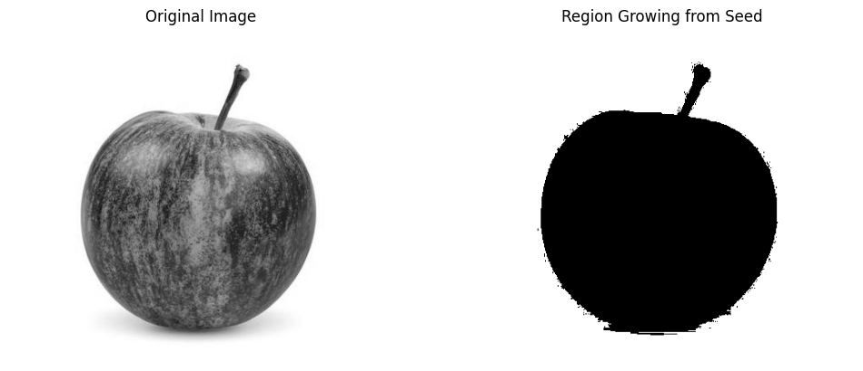

**RESULT:**

Each method segments the image differently: thresholding creates a binary image, graph cut isolates objects, mean shift clusters colors, and K-means simplifies regions. These techniques improve feature extraction and image analysis.

|  |  |
| --- | --- |
| **Date:** 27/03/25  **Ex. No:** 11 | **BACKGROUND SUBTRACTION** |

**AIM:**

To do Averaging , scene change detection and background subtraction for given video.

# **AVERAGEING:**

**Initialize Parameters:** Set the learning rate (alpha) and video configurations (frame size, FPS)

**Capture Video:** Open the video file or webcam feed.

**Preprocess Frames:** Resize each frame, convert it to grayscale, and apply Gaussian blur.

**Background Model:** If uninitialized, assign the first frame as the background model.

**Update Background:** Use a running average (cv2.accumulateWeighted) to update the background model.

**Foreground Detection:** Compute the difference between the current frame and the background, then apply thresholding to create a binary mask.

**Display Frames:** Show the original frame, background model, and foreground mask.

**User Control:** Wait for a key press to continue or exit if 'q' is pressed. Release resources when done.

**CODE SNIPPET:**

import cv2

import numpy as np

import os

alpha = 0.01

output_folder = r"C:\Users\yuval\OneDrive\Documents\motion_output"

os.makedirs(output_folder, exist_ok=True)

fps = 20.0

frame_size = (640, 480)

cap = cv2.VideoCapture(r"C:\Users\yuval\Downloads\6824077-uhd_2160_3840_30fps.mp4")

bg_model = None

while True:

ret, frame = cap.read()

if not ret:

print("End of video.")

break

frame = cv2.resize(frame, frame_size)

gray = cv2.cvtColor(frame, cv2.COLOR_BGR2GRAY)

gray = cv2.GaussianBlur(gray, (5, 5), 0)

if bg_model is None:

bg_model = gray.astype("float")

continue

cv2.accumulateWeighted(gray, bg_model, alpha)

bg_diff = cv2.absdiff(gray, cv2.convertScaleAbs(bg_model))

_, mask = cv2.threshold(bg_diff, 25, 255, cv2.THRESH_BINARY)

cv2.imshow("Frame", frame)

cv2.imshow("Background", cv2.convertScaleAbs(bg_model))

cv2.imshow("Foreground Mask", mask)

key = cv2.waitKey(0) & 0xFF

if key == ord('q'):

print("Exiting...")

break

cap.release()

cv2.destroyAllWindows()

**OUTPUT:**

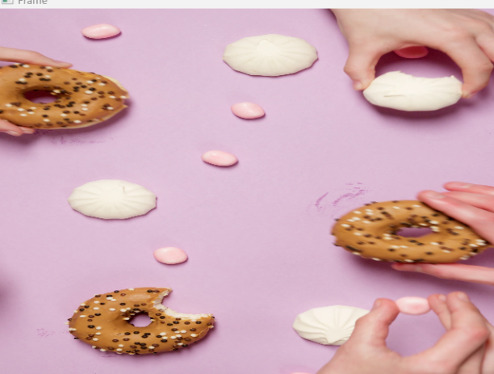 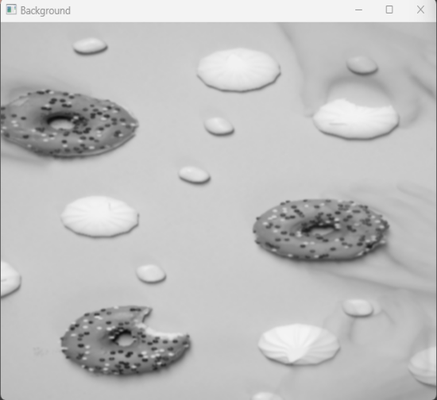

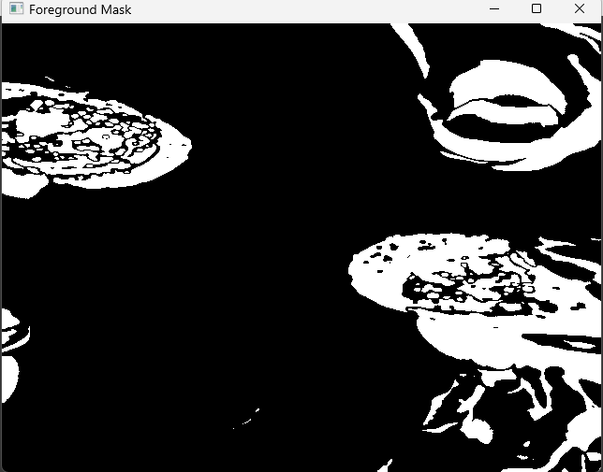

**SCENE CHANGE** **DETECTION:**

**Initialize Parameters:** Set the threshold, create an output folder, and open the video file.

**Frame Preprocessing:** Convert frames to grayscale and calculate histogram differences between consecutive frames.

**Scene Detection:** Detect a scene change if the histogram difference is below the threshold.

**Save Scene Frames:** Save the detected scene change frames as images.

**Display and Exit:** Display the video frames with the difference value until 'q' is pressed, then release resources.

**CODE SNIPPET:**

threshold = 0.5

output_folder = r"C:\Users\yuval\OneDrive\Documents\scene"

os.makedirs(output_folder, exist_ok=True)

cap = cv2.VideoCapture(r"C:\Users\yuval\Downloads\scene.mp4")

frame_count = 0

scene_count = 0

prev_frame = None

def calculate_histogram_difference(frame1, frame2):

hist1 = cv2.calcHist([frame1], [0], None, [256], [0, 256])

hist2 = cv2.calcHist([frame2], [0], None, [256], [0, 256])

cv2.normalize(hist1, hist1, 0, 1, cv2.NORM_MINMAX)

cv2.normalize(hist2, hist2, 0, 1, cv2.NORM_MINMAX)

diff = cv2.compareHist(hist1, hist2, cv2.HISTCMP_CORREL)

return diff

while True:

ret, frame = cap.read()

if not ret:

print("End of video or error reading frame.")

break

frame_count += 1

gray = cv2.cvtColor(frame, cv2.COLOR_BGR2GRAY)

if prev_frame is not None:

diff = calculate_histogram_difference(prev_frame, gray)

if diff < threshold:

scene_count += 1

print(f"Scene Change Detected at frame {frame_count} (Difference: {diff:.2f})")

cv2.imwrite(os.path.join(output_folder, f"scene_{scene_count}.png"), frame)

cv2.putText(frame, f"Diff: {diff:.2f}", (10, 30),

cv2.FONT_HERSHEY_SIMPLEX, 1, (0, 255, 0), 2)

prev_frame = gray

cv2.imshow("Frame", frame)

if cv2.waitKey(0) & 0xFF == ord('q'):

break

cap.release()

cv2.destroyAllWindows()

print(f"Total Scenes Detected: {scene_count}")

**OUTPUT:**

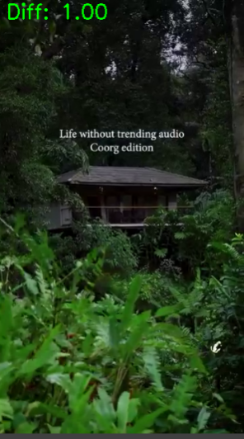 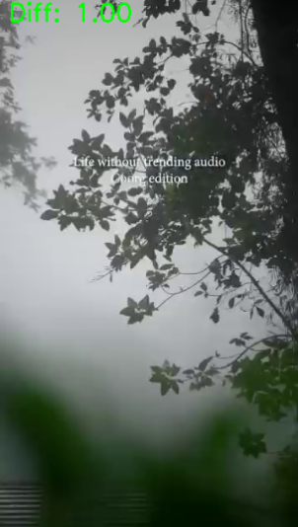 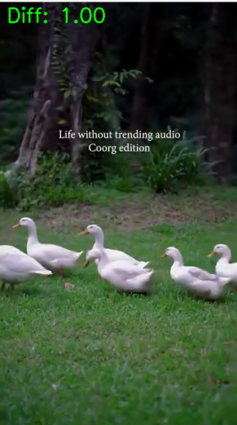 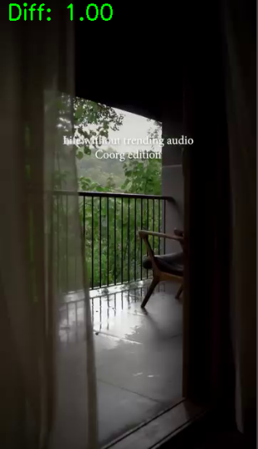

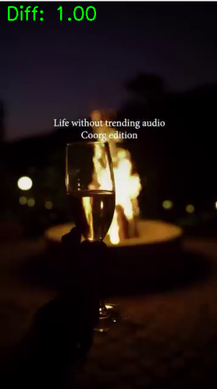

Scene Change Detected at frame 147 (Difference: 0.36)

Scene Change Detected at frame 198 (Difference: -0.02)

Scene Change Detected at frame 263 (Difference: 0.40)

Scene Change Detected at frame 463 (Difference: 0.35)

Scene Change Detected at frame 555 (Difference: 0.19)

End of video or error reading frame.

Total Scenes Detected: 5

**BACKGROUND SUBTRAC****TION:**

**Initialize Background Subtractor:** Use MOG2 with shadow detection and varThreshold settings.

**Capture and Preprocess Frames:** Resize frames and apply background subtraction.

**Post-Processing:** Threshold the mask and apply dilation to enhance object regions.

**Contour Detection:** Identify and draw bounding boxes around moving objects.

**Display and Exit:** Show the results until 'q' or 'Esc' is pressed, then release resources.

**CODE SNIPPET:**

output_folder = r"C:\Users\yuval\OneDrive\Documents\motion_output"

os.makedirs(output_folder, exist_ok=True)

output_file = os.path.join(output_folder, "motion_output.mp4")

cap = cv2.VideoCapture(r"C:\Users\yuval\Downloads\6824077-uhd_2160_3840_30fps.mp4")

frame_width = 1080

frame_height = 1080

fps = int(cap.get(cv2.CAP_PROP_FPS))

out = cv2.VideoWriter(output_file, cv2.VideoWriter_fourcc(*'mp4v'), fps, (frame_width, frame_height))

ret, prev_frame = cap.read()

prev_frame = cv2.resize(prev_frame, (frame_width, frame_height)) # Resize to match processing size

prev_gray = cv2.cvtColor(prev_frame, cv2.COLOR_BGR2GRAY)

while True:

ret, frame = cap.read()

if not ret:

break

frame = cv2.resize(frame, (frame_width, frame_height))

gray = cv2.cvtColor(frame, cv2.COLOR_BGR2GRAY)

diff = cv2.absdiff(prev_gray, gray)

_, motion_mask = cv2.threshold(diff, 50, 255, cv2.THRESH_BINARY)

motion_color = cv2.cvtColor(motion_mask, cv2.COLOR_GRAY2BGR)

out.write(motion_color)

cv2.imshow('Original Frame', frame)

cv2.imshow('Motion Mask', motion_mask)

prev_gray = gray.copy()

if cv2.waitKey(30) & 0xFF == ord('q'):

break

cap.release()

out.release()

cv2.destroyAllWindows()

print(f"Motion detection output saved at: {output_file}")

**OUTPUT:**

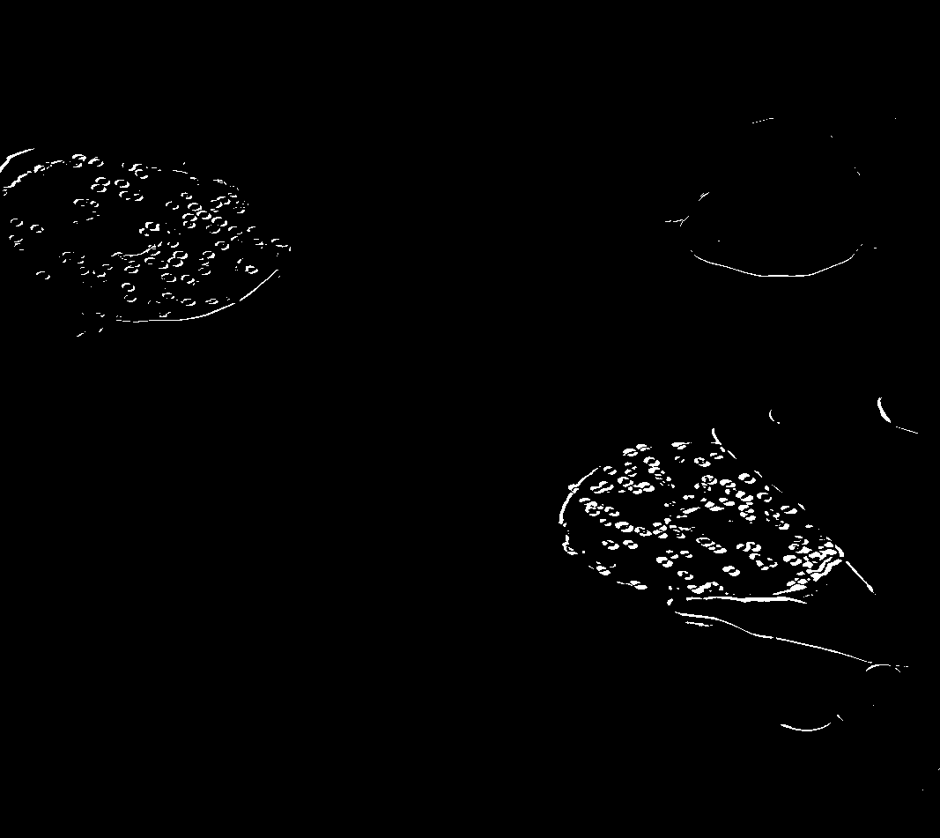

**RESULT:**

The Averaging , scene change detection and background subtraction for video is done successfully.

**LUCAS – KANADE ALGORITHM**

**Ex No : 12**

**Date : 03/04/25**

**AIM :**

To perform Lucas- Kanade optical flow algorithm for motion analysis.

**FUNCTIONS :**

**1. cv2.VideoCapture(path)**

* Opens a video file for reading frame-by-frame.

**2. cap.read()**

* Reads the next frame from the video.
* Returns a boolean (ret) and the frame (frame).

**3. cv2.cvtColor(src, code)**

* Converts the image from one color format to another (e.g., BGR to RGB or Grayscale).

**4. cv2.goodFeaturesToTrack(image, mask, **params)**

* Detects good features (corners) in an image using Shi-Tomasi method.
* Used to initialize points for optical flow tracking.

**5. cv2.calcOpticalFlowPyrLK(prevImg, nextImg, prevPts, nextPts, **params)**

* Computes optical flow for sparse features using the Lucas-Kanade method.
* Returns new positions of tracked points and a status vector.

**6. cv2.line(img, pt1, pt2, color, thickness)**

* Draws a line between two points on an image (used to visualize motion).

**7. cv2.circle(img, center, radius, color, thickness)**

* Draws a circle on the image at a given coordinate.

**8. cv2.imshow(window_name, image)**

* Displays an image in a named window.

**9. cv2.waitKey(delay)**

* Waits for a key press for a specific time in milliseconds.
* Returns the ASCII code of the pressed key.

**10. cv2.destroyAllWindows()**

* Closes all OpenCV windows opened using imshow.

**11. cv2.add(image1, image2)**

* Adds two images pixel-by-pixel (used to overlay flow lines on frames).

**ALGORITHM :**

**1. Read and Display First Two Frames from Video**

**Algorithm:**

1. Open the video using cv2.VideoCapture().
2. Read the first two frames using cap.read().
3. Convert both frames from BGR to RGB (for matplotlib display).
4. Plot both frames side-by-side using matplotlib.pyplot.

**2. Lucas-Kanade Optical Flow on Two Static Images**

**Algorithm:**

1. Load two image frames using cv2.imread().
2. Resize the second frame to match the size of the first.
3. Convert both frames to grayscale using cv2.cvtColor().
4. Detect good features in the first frame using cv2.goodFeaturesToTrack().
5. Apply Lucas-Kanade Optical Flow (cv2.calcOpticalFlowPyrLK) to track feature motion from frame1 to frame2.
6. For each tracked feature:
   * Draw a green line showing motion.
   * Draw a red circle at the new position.
7. Convert the annotated image to RGB and display using matplotlib.pyplot.

**3. Lucas-Kanade Optical Flow Tracking Over Entire Video**

**Algorithm:**

1. Open the video and read the first frame.
2. Convert the first frame to grayscale.
3. Detect good features in the first frame using cv2.goodFeaturesToTrack().
4. Loop through the remaining video frames:
   * Convert the new frame to grayscale.
   * Track features using cv2.calcOpticalFlowPyrLK().
   * For each feature:
     + Draw a green line for motion.
     + Draw a red circle at the new position.
   * Overlay the drawn mask on the new frame and display using cv2.imshow().
   * Update previous frame and feature points for the next iteration.
   * Stop if the user presses 'q'.
5. Release video and close all OpenCV windows.

CODE SNIPPET :

import cv2

import matplotlib.pyplot as plt

video_path = r"C:\Users\student\Downloads\13205231_1920_1080_24fps.mp4"

cap = cv2.VideoCapture(video_path)

ret1, frame1 = cap.read()

ret2, frame2 = cap.read()

cap.release()

if ret1 and ret2:

    frame1 = cv2.cvtColor(frame1, cv2.COLOR_BGR2RGB)

    frame2 = cv2.cvtColor(frame2, cv2.COLOR_BGR2RGB)

    plt.figure(figsize=(10, 5))

    plt.subplot(1, 2, 1)

    plt.imshow(frame1)

    plt.title("Frame 1")

    plt.axis("off")

    plt.subplot(1, 2, 2)

    plt.imshow(frame2)

    plt.title("Frame 2")

    plt.axis("off")

    plt.show()

else:

    print("Error: Could not read frames from video.")

**OUTPUT:**

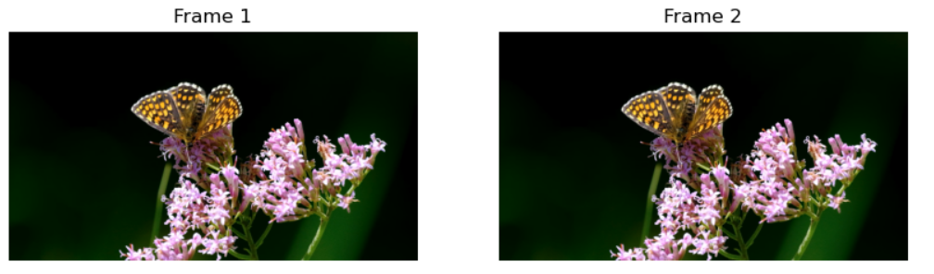

import cv2

import numpy as np

import matplotlib.pyplot as plt

frame1 = cv2.imread(r"C:\Users\student\Pictures\Screenshots\frame1.png")

frame2 = cv2.imread(r"C:\Users\student\Pictures\Screenshots\frame2.png")

if frame1 is None or frame2 is None:

    print("Error: Could not load frames.")

    exit()

frame2 = cv2.resize(frame2, (frame1.shape[1], frame1.shape[0]))

gray1 = cv2.cvtColor(frame1, cv2.COLOR_BGR2GRAY)

gray2 = cv2.cvtColor(frame2, cv2.COLOR_BGR2GRAY)

feature_params = dict(maxCorners=100, qualityLevel=0.3, minDistance=7, blockSize=7)

p0 = cv2.goodFeaturesToTrack(gray1, mask=None, **feature_params)

if p0 is None:

    print("No good features found in frame1.")

    exit()

lk_params = dict(winSize=(15, 15), maxLevel=2,

                 criteria=(cv2.TERM_CRITERIA_EPS | cv2.TERM_CRITERIA_COUNT, 10, 0.03))

p1, st, err = cv2.calcOpticalFlowPyrLK(gray1, gray2, p0, None, **lk_params)

if p1 is not None and st is not None:

    good_new = p1[st == 1]

    good_old = p0[st == 1]

    for i, (new, old) in enumerate(zip(good_new, good_old)):

        a, b = new.ravel()

        c, d = old.ravel()

        frame2 = cv2.line(frame2, (int(a), int(b)), (int(c), int(d)), (0, 255, 0), 2)

        frame2 = cv2.circle(frame2, (int(a), int(b)), 5, (0, 0, 255), -1)

    frame2_rgb = cv2.cvtColor(frame2, cv2.COLOR_BGR2RGB)

    plt.figure(figsize=(8, 6))

    plt.imshow(frame2_rgb)

    plt.title("Lucas-Kanade Optical Flow")

    plt.axis("off")  # Hide axes

    plt.show()

else:

    print("Optical flow could not be calculated.")

**OUTPUT:**

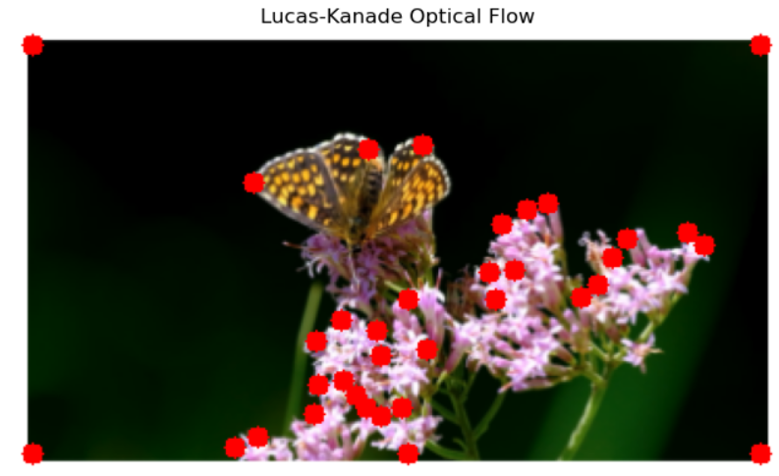

import cv2

import numpy as np

video_path = r"C:\Users\student\Downloads\13205231_1920_1080_24fps.mp4"

cap = cv2.VideoCapture(video_path)

if not cap.isOpened():

    print("Error: Could not open video.")

    exit()

ret, old_frame = cap.read()

if not ret:

    print("Error: Could not read first frame.")

    exit()

old_gray = cv2.cvtColor(old_frame, cv2.COLOR_BGR2GRAY)

feature_params = dict(maxCorners=200, qualityLevel=0.3, minDistance=7, blockSize=7)

p0 = cv2.goodFeaturesToTrack(old_gray, mask=None, **feature_params)

lk_params = dict(winSize=(15, 15), maxLevel=2,

                 criteria=(cv2.TERM_CRITERIA_EPS | cv2.TERM_CRITERIA_COUNT, 10, 0.03))

mask = np.zeros_like(old_frame)

while cap.isOpened():

    ret, new_frame = cap.read()

    if not ret:

        break

    new_gray = cv2.cvtColor(new_frame, cv2.COLOR_BGR2GRAY)

    p1, st, err = cv2.calcOpticalFlowPyrLK(old_gray, new_gray, p0, None, **lk_params)

    if p1 is not None and st is not None:

        good_new = p1[st == 1]

        good_old = p0[st == 1]

        for i, (new, old) in enumerate(zip(good_new, good_old)):

            a, b = new.ravel()

            c, d = old.ravel()

            mask = cv2.line(mask, (int(a), int(b)), (int(c), int(d)), (0, 255, 0), 2)

            new_frame = cv2.circle(new_frame, (int(a), int(b)), 5, (0, 0, 255), -1)

        output = cv2.add(new_frame, mask)

        cv2.imshow('Optical Flow - Lucas Kanade', output)

        old_gray = new_gray.copy()

        p0 = good_new.reshape(-1, 1, 2)

        if cv2.waitKey(25) & 0xFF == ord('q'):

            break

    else:

        break

cap.release()

cv2.destroyAllWindows()

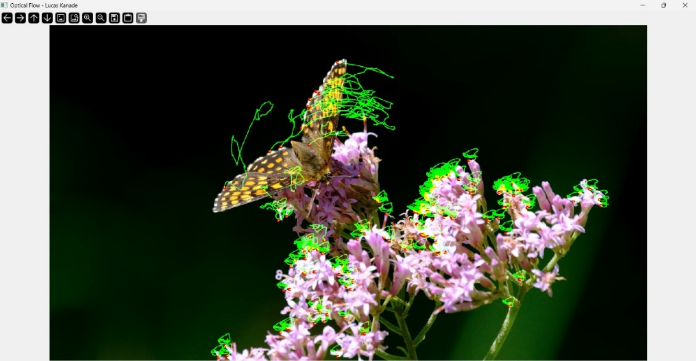

**RESULT :**

Thus, Lucas – Kanade optical flow algorithm was performed successfully.